# Begin!

LẬP TRÌNH C# - SOLOLEARN

**Student : Green Wolf**

**Date : 27 / 12 / 2020**

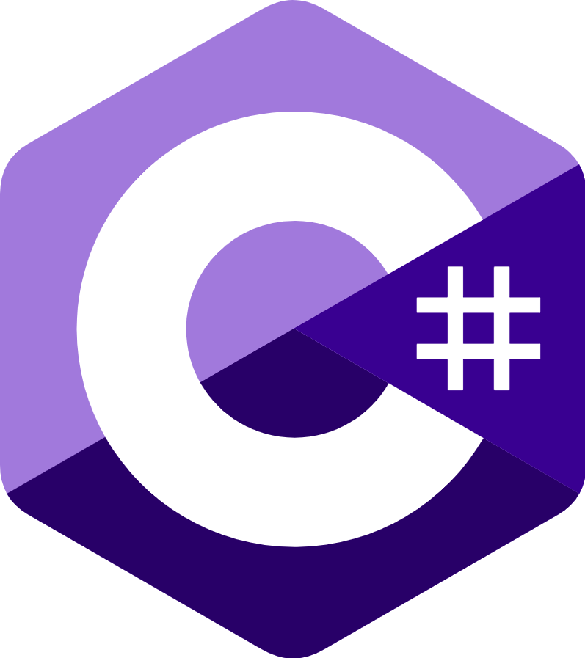

# Basic Concepts

## What is C#?

**Welcome to C#**

C# is an elegant object-oriented language that enables developers to build a variety of secure and robust applications that run on the **.NET Framework.**

You can use C# to create Windows applications, Web services, mobile applications, client-server applications, database applications, and much, much more.

You will learn more about these concepts in the upcoming lessons!

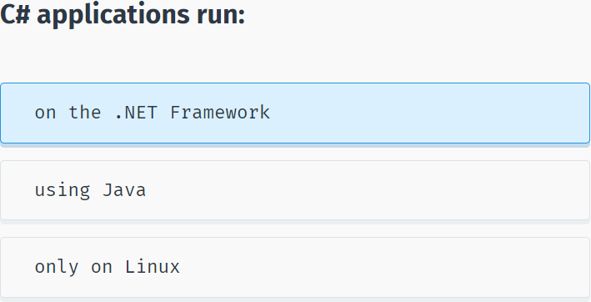

**The .NET Framework**

The .NET Framework consists of the **Common Language Runtime (CLR)** and the .NET Framework **class library**.

The **CLR** is the foundation of the .NET Framework. It manages code at execution time, providing core services such as memory management, code accuracy, and many other aspects of your code.

The **class library** is a collection of classes, interfaces, and value types that enable you to accomplish a range of common programming tasks, such as data collection, file access, and working with text.

C# programs use the .NET Framework class library extensively to do common tasks and provide various functionalities.

These concepts might seem complex, but for now just remember that applications written in C# use the **.NET Framework** and its components.

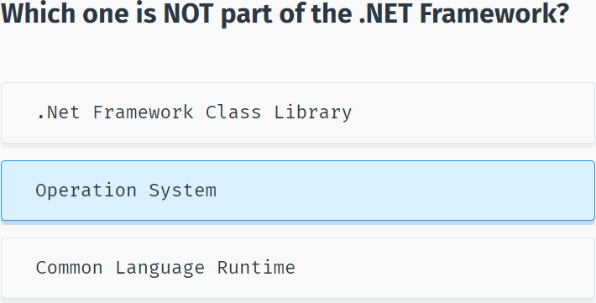

## Variables

**Variables**

Programs typically use data to perform tasks.

Creating a **variable** reserves a memory location, or a space in memory, for storing values. It is called **variable** because the information stored in that location can be changed when the program is running.

To use a variable, it must first be declared by specifying the **name** and **data type**.

A variable name, also called an **identifier**, can contain letters, numbers and the underscore character (_) and must start with a letter or underscore.

Although the name of a variable can be any set of letters and numbers, the best identifier is descriptive of the data it will contain. This is very important in order to create clear, understandable and readable code!

For example, **firstName** and **lastName** are good descriptive variable names, while **abc** and **xyz** are not.

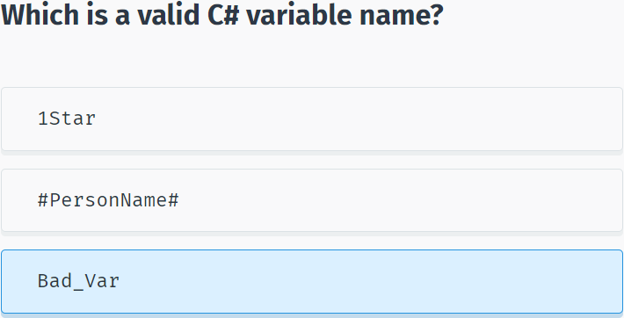

**Variable Types**

A **data type** defines the information that can be stored in a variable, the size of needed memory and the operations that can be performed with the variable.

For example, to store an integer value (a whole number) in a variable, use the **int** keyword:

int myAge;

The code above declares a variable named **myAge** of type **integer**.

A line of code that completes an action is called a statement. Each statement in C# must end with a **semicolon “;”**.

You can assign the value of a variable when you declare it:

int myAge = 18;

or later in your code:

int myAge;

myAge = 18;

Remember that you need to declare the variable before using it.

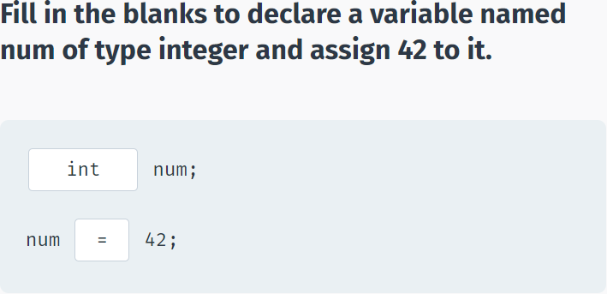

**Built-in Data Types**

There are a number of built-in data types in C#. The most common are:

**int** - integer.

**float** - floating point number.

**double** - double-precision version of float.

**char** - a single character.

**bool** - Boolean that can have only one of two values: True or False.

**string** - a sequence of characters.

The statements below use C# data types:

int ​x = 42;

double ​pi = 3.14;

char y = 'Z’;

bool ​isOnline = true;

string ​firstName = "David”;

Note that **char** values are assigned using single quotes and **string** values require double quotes.

You will learn how to perform different operations with variables in the upcoming lessons!

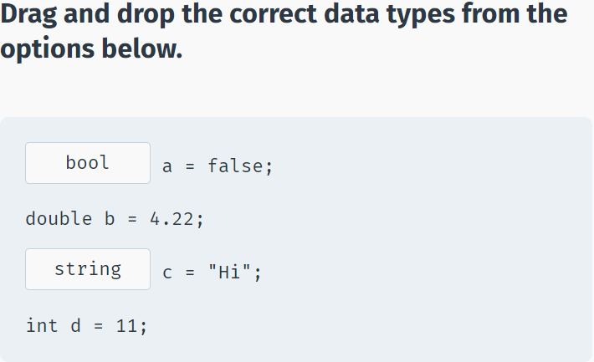

## Your First C# Program

**Your First C# Program**

You can run, save, and share your C# codes on our **Code Playground**, without installing any additional software.

Reference this lesson if you need to install the software on your computer.

To create a C# program, you need to install an integrated development environment (IDE) with coding and debugging tools.

We will be using **Visual Studio Community Edition**, which is available to download for free.

After installing it, choose the default configuration.

Next, click **File->New->Project** and then choose **Console Application** as shown below:

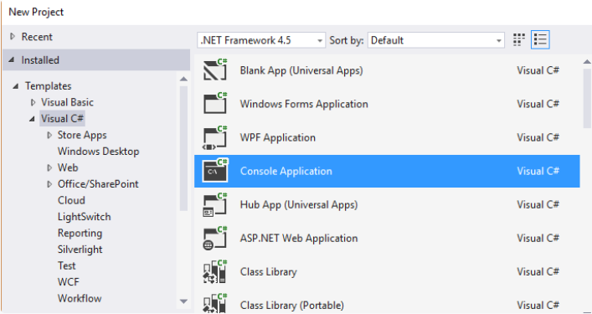

Enter a name for your Project and click OK.

**Console application** uses a text-only interface. We chose this type of application to focus on learning the fundamentals of C#.

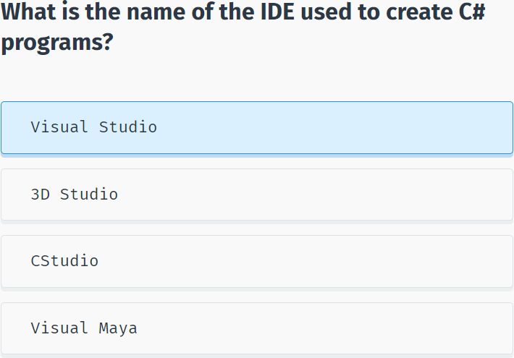

Visual Studio will automatically generate some code for your project:

using System;

using System.Collections.Generic;

using System.Linq;

using System.Text;

using System.Threading.Tasks;

namespace SoloLearn

{

class Program

{

static void Main(string[] args)

{

}

}

}

You will learn what each of the statements does in the upcoming lessons.

For now, remember that every C# console application must contain a **method (a function) named Main**. Main is the starting point of every application, i.e. the point where our program starts execution from.

We will learn about classes, methods, arguments, and namespaces in the upcoming lessons.

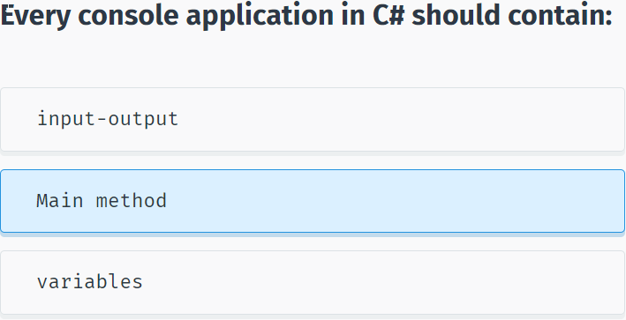

To run your program, press **Ctrl+F5**. You will see the following screen:

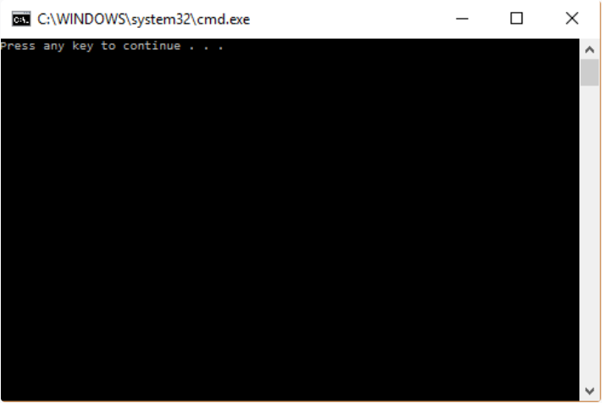

This is a console window. As we did not have any statements in our **Main** method, the program just produces a general message. Pressing any key will close the console.

Congratulations, you just created your first C# program.

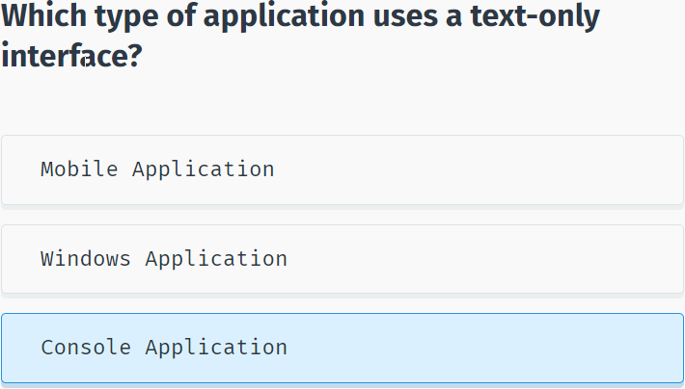

## Printing Text

**Displaying Output**

Most applications require some **input** from the user and give **output** as a result.

To display text to the console window you use the **Console.Write** or **Console.WriteLine** methods. The difference between these two is that **Console.WriteLine** is followed by a line terminator, which moves the cursor to the next line after the text output.

The program below will display Hello World! to the console window:

using System;

using System.Collections.Generic;

using System.Linq;

using System.Text;

using System.Threading.Tasks;

namespace SoloLearn

{

class Program

{

static void Main(string[] args)

{

Console.WriteLine("Hello World!");

}

}

}

Note the **parentheses** after the **WriteLine** method. This is the way to pass data, or arguments, to methods. In our case **WriteLine** is the method and we pass "Hello World!" to it as an argument. String arguments must be enclosed in quotation marks.

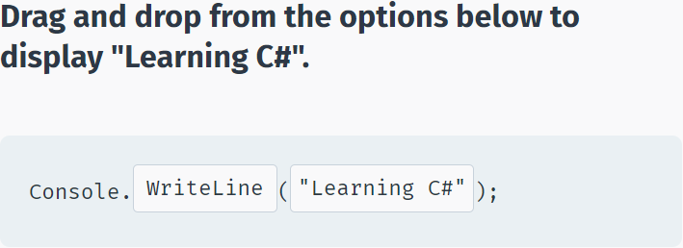

We can display variable values to the console window:

int x = 89;

Console.WriteLine(x);//89

To display a **formatted string**, use the following syntax:

int x = 10;

double y = 20;

Console.WriteLine("x = {0}; y = {1}", x, y);

//x = 10; y = 20

As you can see, the value of **x** replaced **{0}** and the value of **y** replaced **{1}**.

You can have as many variable placeholders as you need. (i.e.: {3}, {4}, etc.).

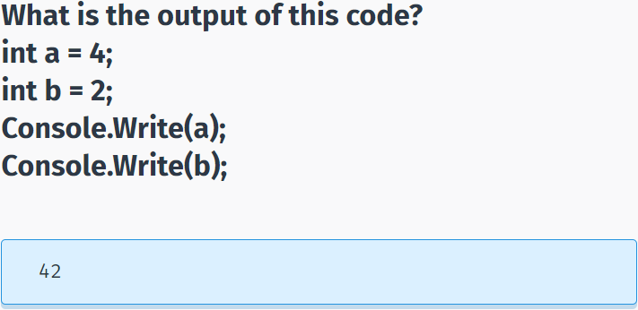

## Getting User Input

**User Input**

You can also prompt the user to enter data and then use the **Console.ReadLine** method to assign the input to a string variable.

The following example asks the user for a name and then displays a message that includes the input:

string yourName;

Console.WriteLine("What is your name?");

yourName = Console.ReadLine();//->Green

Console.WriteLine("Hello {0}", yourName);

//What is your name?

//Green

The **Console.ReadLine** method waits for user input and then assigns it to the variable. The next statement displays a formatted string containing Hello with the user input. For example, if you enter David, the output will be Hello David.

Note the empty parentheses in the **ReadLine** method. This means that it does not take any arguments.

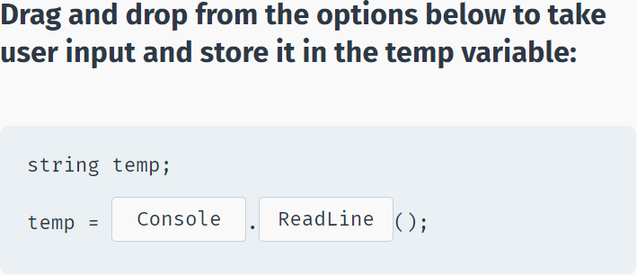

The **Console.ReadLine()** method returns a **string** value.

If you are expecting another type of value (such as int or double), the entered data must be converted to that type.

This can be done using the **Convert.ToXXX** methods, where XXX is the .NET name of the type that we want to convert to. For example, methods include **Convert.ToDouble** and **Convert.ToBoolean**.

For integer conversion, there are three alternatives available based on the bit size of the integer: **Convert.ToInt16**, **Convert.ToInt32** and **Convert.ToInt64**. The default int type in C# is 32-bit.

Let’s create a program that takes an integer as input and displays it in a message:

int age = Convert.ToInt32(Console.ReadLine());

Console.WriteLine("You are {0} years old", age);

If, in the program above, a non-integer value is entered (for example, letters), the **Convert** will fail and cause an error.

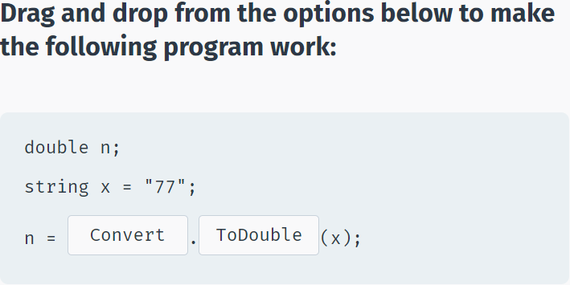

## Comments

**Comments**

**Comments** are explanatory statements that you can include in a program to benefit the reader of your code.

The compiler ignores everything that appears in the comment, so none of that information affects the result.

A comment beginning with two slashes (//) is called a single-line comment. The slashes tell the compiler to ignore everything that follows, until the end of the line.

// Prints Hello

Console.WriteLine("Hello");

When you run this code, Hello will be displayed to the screen. The // Prints Hello line is a comment and will not appear as output.

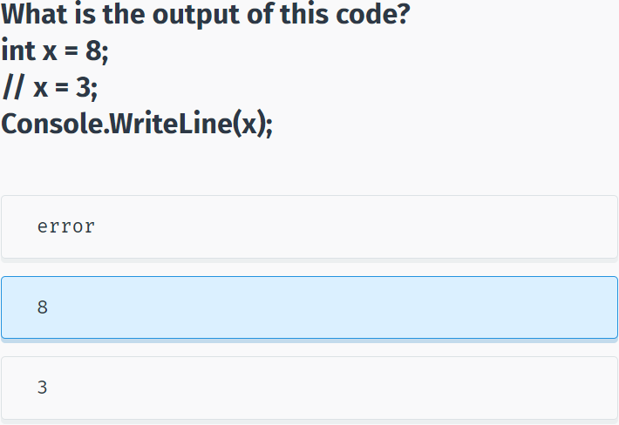

**Multi-Line Comments**

Comments that require multiple lines begin with /* and end with */ at the end of the comment block.

You can place them on the same line or insert one or more lines between them.

/* Some long

comment text

*/

int x = 42;

Console.WriteLine(x);//42

Adding comments to your code is good programming practice. It facilitates a clear understanding of the code for you and for others who read it.

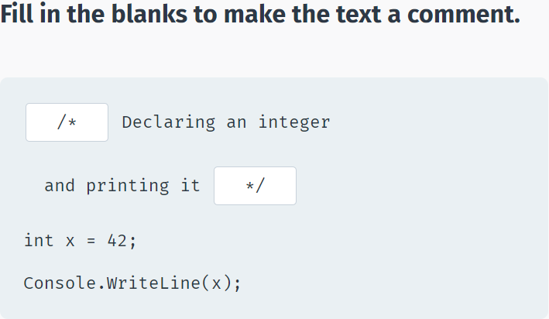

## The var Keyword

**The var Keyword**

A variable can be explicitly declared with its **type** before it is used.

Alternatively, C# provides a handy function to enable the compiler to determine the type of the variable automatically based on the expression it is assigned to.

**The var keyword is used for those scenarios:**

var num = 15;

The code above makes the compiler determine the type of the variable. Since the value assigned to the variable is an integer, the variable will be declared as an integer automatically.

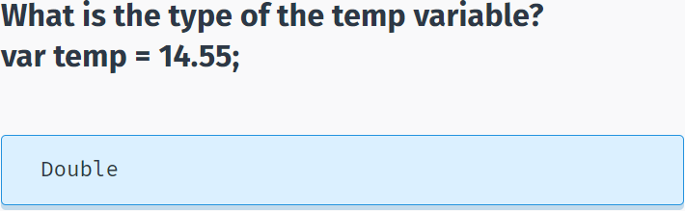

Variables declared using the var keyword are called **implicitly typed** variables.

Implicitly typed variables must be initialized with a value.

**For example, the following program will cause an error:**

var num;

num = 42;->error!

Although it is easy and convenient to declare variables using the **var** keyword, overuse can harm the readability of your code. Best practice is to explicitly declare variables.

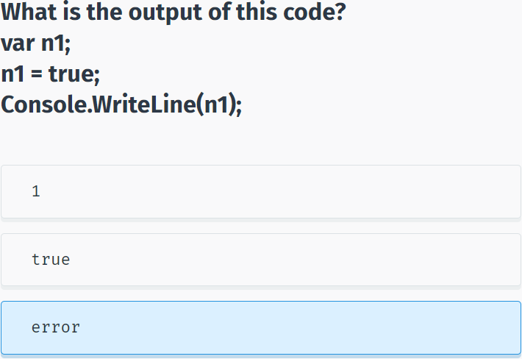

## Constants

**Constants**

**Constants** store a value that cannot be changed from their initial assignment.

To declare a constant, use the **const** modifier.

**For example:**

const double PI = 3.14;

The value of const PI cannot be changed during program execution.

For example, an assignment statement later in the program will cause an error:

const double PI = 3.14;

PI = 8; ->error

Constants **must** be initialized with a value when declared.

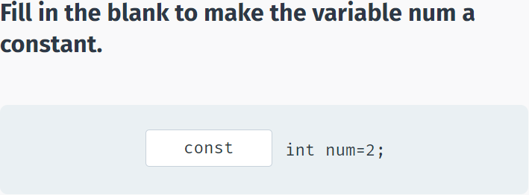

## Arithmetic Operators

**Operators**

An **operator** is a symbol that performs mathematical or logical manipulations.

**Arithmetic Operators**

C# supports the following arithmetic operators:

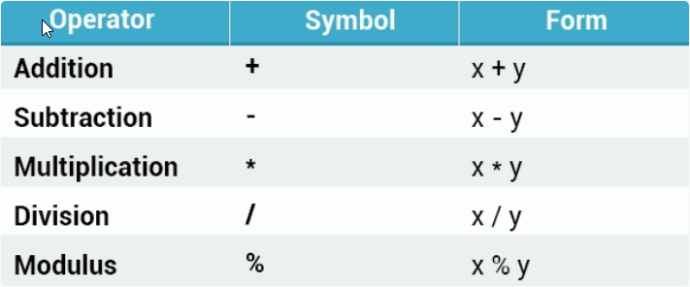

**For example:**

int x = 10;

int y = 4;

Console.WriteLine(x-y);//6

Tap **Try It Yourself** to play around with the code!

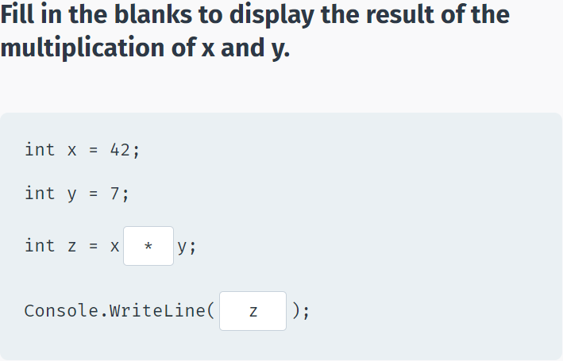

**Division**

The division operator (/) divides the first operand by the second. If the operands are both integers, any remainder is dropped in order to return an integer value.

**Example:**

int x = 10 / 4;

Console.WriteLine(x);//2

Division by 0 is undefined and will crash your program.

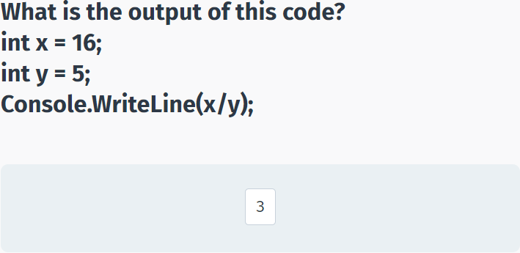

**Modulus**

The modulus operator (%) is informally known as the remainder operator because it returns the remainder of an integer division.

**For example:**

int x = 25 % 7;

Console.WriteLine(x);//4

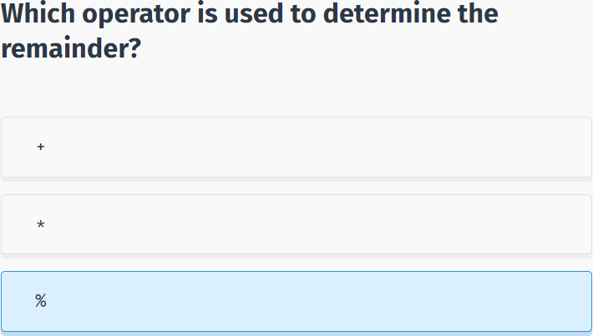

**Operator Precedence**

Operator **precedence** determines the grouping of terms in an expression, which affects how an expression is evaluated. Certain operators take higher precedence over others; for example, the multiplication operator has higher precedence than the addition operator.

**For example:**

int x = 4+3*2;

Console.WriteLine(x);//10

The program evaluates 3*2 first, and then adds the result to 4.

As in mathematics, using **parentheses** alters operator precedence.

int x = (4 + 3) *2;

Console.WriteLine(x);//14

The operations within parentheses are performed first. If there are parenthetical expressions nested within one another, the expression within the innermost parentheses is evaluated first.

If none of the expressions are in parentheses, multiplicative (multiplication, division, modulus) operators will be evaluated before additive (addition, subtraction) operators. Operators of equal precedence are evaluated from left to right.

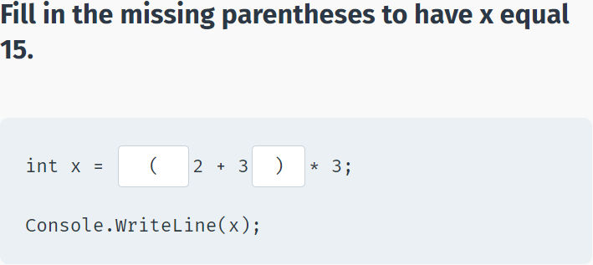

## Assignment & Increment Operators

**Assignment Operators**

The = **assignment** operator assigns the value on the right side of the operator to the variable on the left side.

C# also provides **compound assignment operators** that perform an operation and an assignment in one statement.

**For example:**

int x = 42;

x += 2; // equivalent to x = x + 2

Console.WriteLine(x);//44

x -= 6; // equivalent to x = x - 6

Console.WriteLine(x);//38

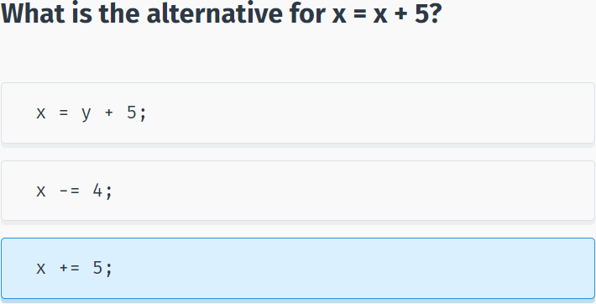

The same shorthand syntax applies to the multiplication, division, and modulus operators.

x *= 8; // equivalent to x = x * 8

x /= 5; // equivalent to x = x / 5

x %= 2; // equivalent to x = x % 2

The same shorthand syntax applies to the multiplication, division, and modulus operators.

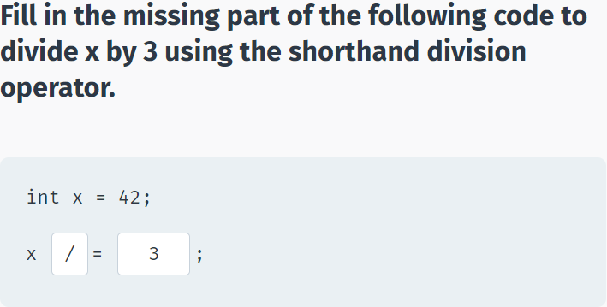

**Increment Operator**

The **increment** operator is used to increase an integer's value by one, and is a commonly used C# operator.

x++; ​//equivalent to x = x + 1

**For example:**

int x = 10;

x++;

Console.WriteLine(x);//11

The increment operator is used to increase an integer's value by one.

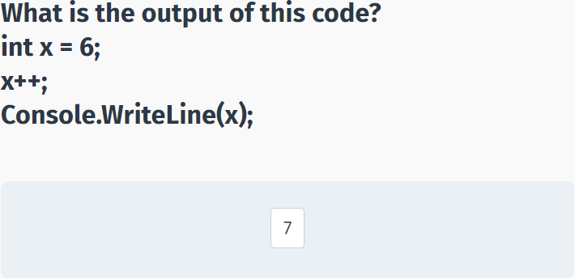

**Prefix & Postfix Forms**

The increment operator has two forms, **prefix** and **postfix**

++x; //prefix

x++; //postfix

**Prefix** increments the value, and then proceeds with the expression.

**Postfix** evaluates the expression and then performs the incrementing.

**Prefix example:**

int x = 3;

int y = ++x;

//x is 4; y is 4

**Postfix example:**

int x = 3;

int y = x++;

//x is 4; y is 3

The **prefix** example increments the value of x, and then assigns it to y.

The **postfix** example assigns the value of x to y, and then increments x.

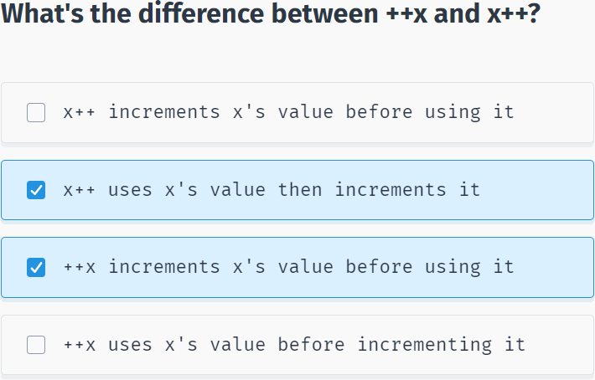

**Decrement Operator**

The **decrement** operator (--) works in much the same way as the increment operator, but instead of increasing the value, it decreases it by one.

--x; // prefix

x--; // postfix

The decrement operator (--) works in much the same way as the increment operator.

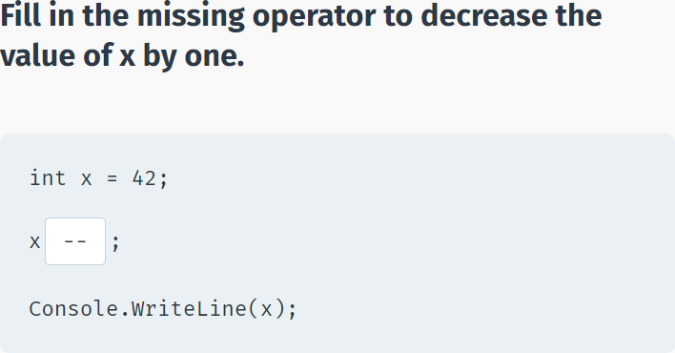

## Module 1 Quiz

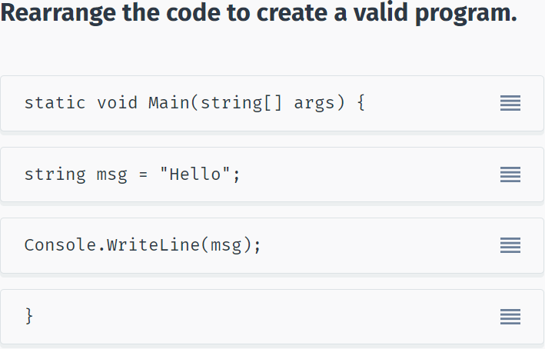

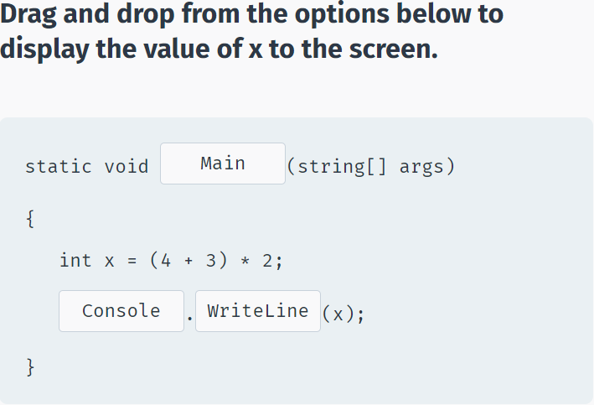

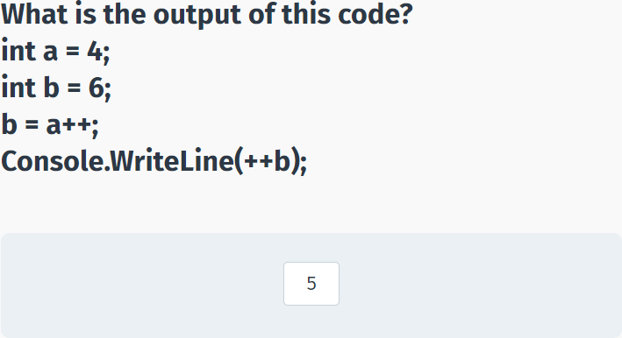

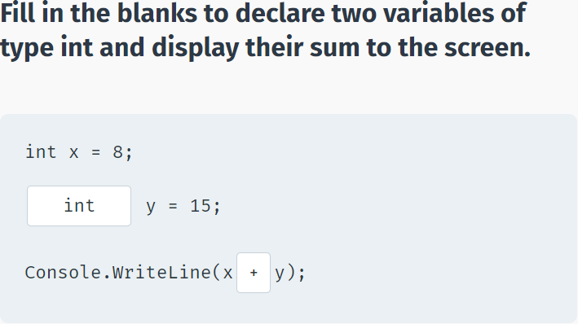

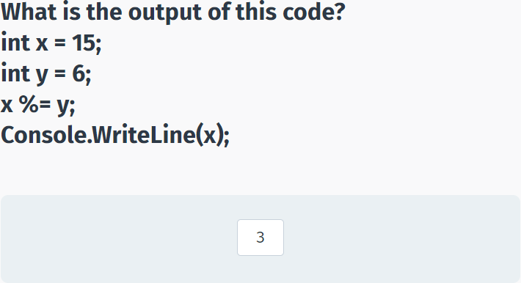

# Conditionals and Loops

## The if-else Statement

**The if Statement**

The **if** statement is a conditional statement that executes a block of code when a condition is true.

**The general form of the if statement is:**

if (condition)

{

// Execute this code when condition is true

}

The condition can be any expression that returns true or false.

**For example:**

int x = 8;

int y = 3;

if (x > y)

{

Console.WriteLine("x is greater than y");

//x is greater than y

}

The code above will evaluate the condition **x > y**. If it is true, the code inside the if block will execute.

When only one line of code is in the if block, the curly braces can be omitted.

For example:

if (x > y)

Console.WriteLine("x is greater than y");

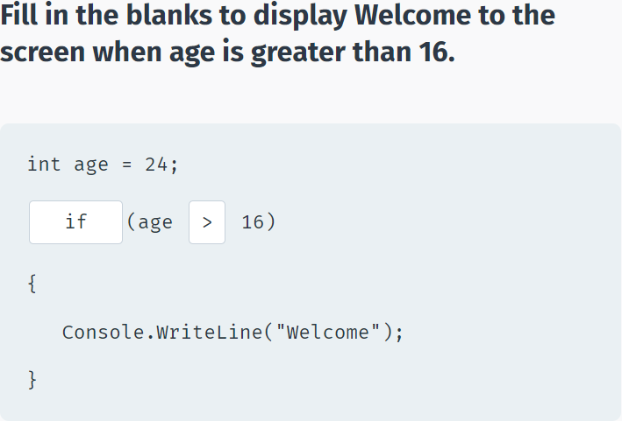

**Relational Operators**

Use **relational operators** to evaluate conditions. In addition to the less than (<) and greater than (>) operators, the following operators are available:

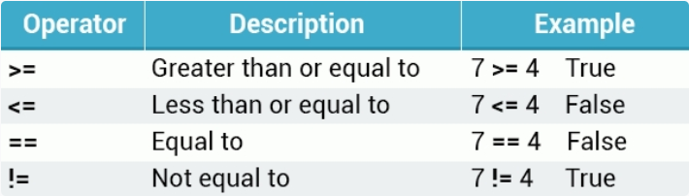

**Example:**

int a=7, b=7;

if (a == b) {

Console.WriteLine("Equal");

//Equal

}

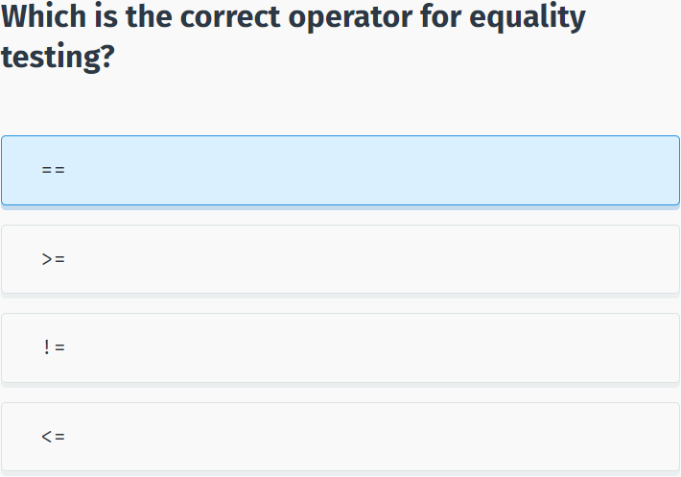

**The else Clause**

An optional **else** clause can be specified to execute a block of code when the condition in the **if** statement evaluates to **false**.

**Syntax:**

if (condition)

{

//statements

}

else

{

//statements

}

**For example:**

int mark = 85;

if (mark < 50)

{

Console.WriteLine("You failed.");

}

else

{

Console.WriteLine("You passed.");

}

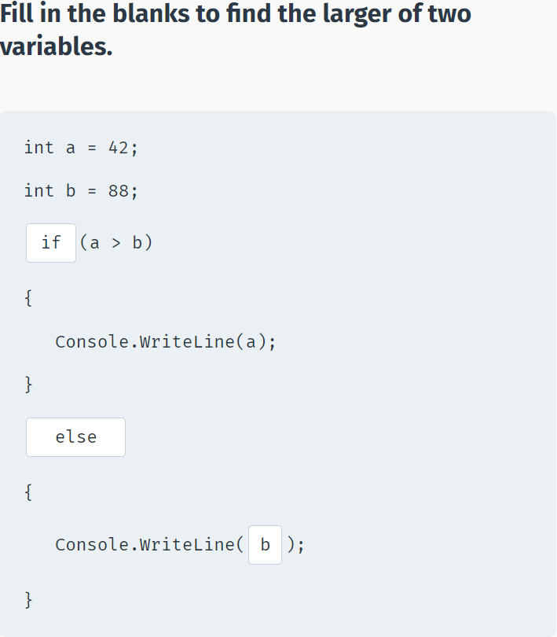

**Nested if Statements**

You can also include, or **nest**, if statements within another if statement.

**For example:**

int mark = 100;

if (mark >= 50) {

Console.WriteLine("You passed.");

if (mark == 100) {

Console.WriteLine("Perfect!");

}

else {

Console.WriteLine("You failed.");

}

You can nest an unlimited number of if-else statements.

**For example:**

using System;

using System.Collections.Generic;

using System.Linq;

using System.Text;

using System.Threading.Tasks;

namespace SoloLearn

{

class Program

{

static void Main(string[] args)

{

int age = 17;

if (age > 14) {

if(age > 18) {

Console.WriteLine("Adult");

}

else {

Console.WriteLine("Teenager");

}

}

else {

if (age > 0) {

Console.WriteLine("Child");

}

else {

Console.WriteLine("Something's wrong");

}

}

}

}

}

Remember that all **else** clauses must have corresponding **if** statements.

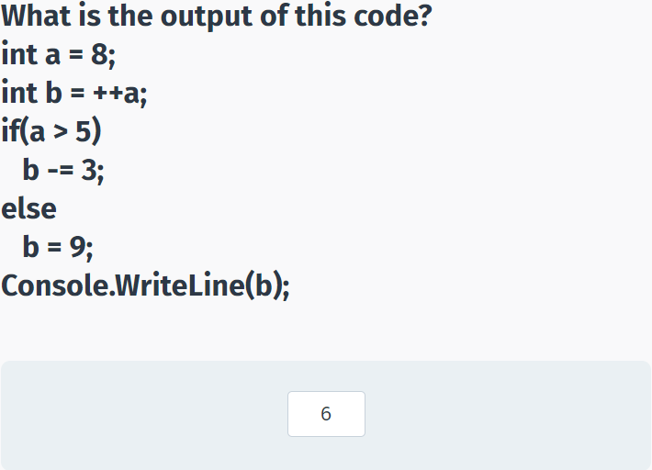

**The if-else if Statement**

The **if-else if** statement can be used to decide among three or more actions.

**For example:**

using System;

using System.Collections.Generic;

using System.Linq;

using System.Text;

using System.Threading.Tasks;

namespace SoloLearn

{

class Program

{

static void Main(string[] args)

{

int x = 33;

if (x == 8) {

Console.WriteLine("Value of x is 8");

}

else if (x == 18) {

Console.WriteLine("Value of x is 18");

}

else if (x == 33) {

Console.WriteLine("Value of x is 33");

}

else {

Console.WriteLine("No match");

}

}

}

}

Remember, that an **if** can have zero or more **else if**'s and they must come before the last **else**, which is optional.

Once an **else if** succeeds, none of the remaining **else if**'s or **else** clause will be tested.

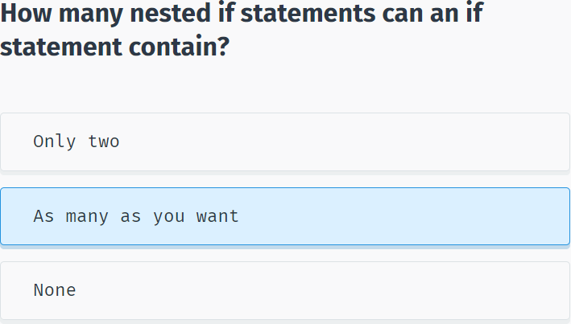

## The switch Statement

**switch**

The **switch** statement provides a more elegant way to test a variable for equality against a list of values.

Each value is called a **case**, and the variable being switched on is checked for each switch case.

**For example:**

using System;

using System.Collections.Generic;

using System.Linq;

using System.Text;

using System.Threading.Tasks;

namespace SoloLearn

{

class Program

{

static void Main(string[] args)

{

int num = 3;

switch (num)

{

case 1:

Console.WriteLine("one");

break;

case 2:

Console.WriteLine("two");

break;

case 3:

Console.WriteLine("three");

break;

}

}

}

}

Each **case** represents a value to be checked, followed by a colon, and the statements to get executed if that case is matched.

A **switch** statement can include any number of **cases**. However, no two case labels may contain the same constant value.

The **break**; statement that ends each **case** will be covered shortly.

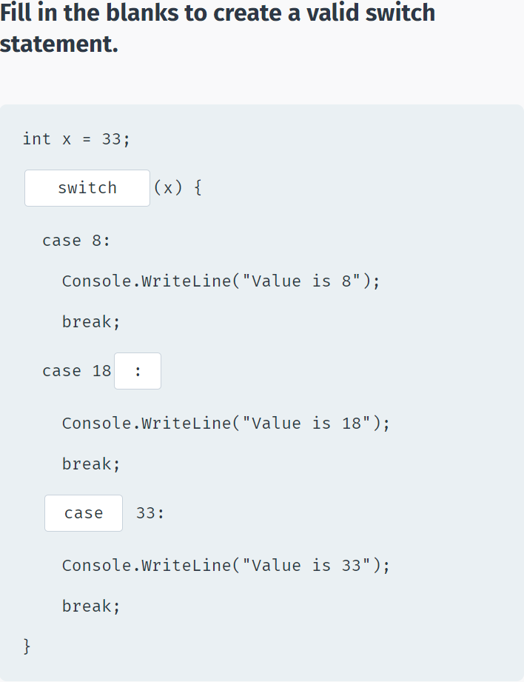

**The default Case**

In a switch statement, the optional **default** case is executed when none of the previous cases match.

**Example:**

using System;

using System.Collections.Generic;

using System.Linq;

using System.Text;

using System.Threading.Tasks;

namespace SoloLearn

{

class Program

{

static void Main(string[] args)

{

int age = 88;

switch (age) {

case 16:

Console.WriteLine("Too young");

break;

case 42:

Console.WriteLine("Adult");

break;

case 70:

Console.WriteLine("Senior");

break;

default:

Console.WriteLine("The default case");

break;

}

}

}

}

The **default** code executes when none of the cases matches the switch expression.

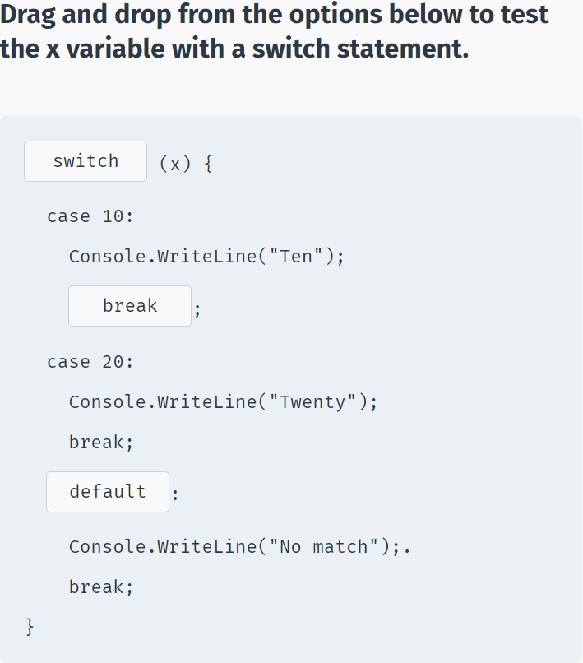

**The break Statement**

The role of the **break** statement is to terminate the **switch** statement.

Without it, execution continues past the matching **case** statements and falls through to the next case statements, even when the case labels don’t match the switch variable.

This behavior is called **fallthrough** and modern C# compilers will not compile such code. All case and default code must end with a **break** statement.

The **break** statement can also be used to break out of a loop. You will learn about loops in the coming lessons.

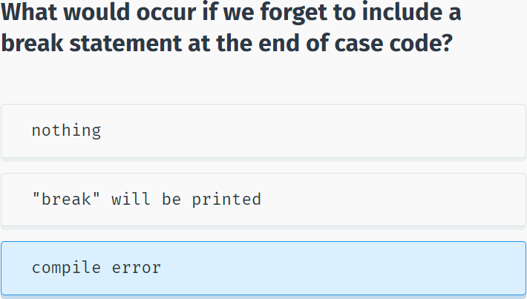

## The while Loop

**while**

A **while** loop repeatedly executes a block of code as long as a given condition is **true**.

**For example, the following code displays the numbers 1 through 5:**

using System;

using System.Collections.Generic;

using System.Linq;

using System.Text;

using System.Threading.Tasks;

namespace SoloLearn

{

class Program

{

static void Main(string[] args)

{

int num = 1;

while(num < 6)

{

Console.WriteLine(num);

num++;

}

}

}

}

The example above declares a variable equal to 1 (int num = 1). The **while** loop checks the condition (num < 6) and, if **true**, executes the statements in its body, which increment the value of **num** by one, before checking the loop condition again.

After the 5th iteration, **num** equals 6, the condition evaluates to **false**, and the loop stops running.

The **loop body** is the block of statements within curly braces.

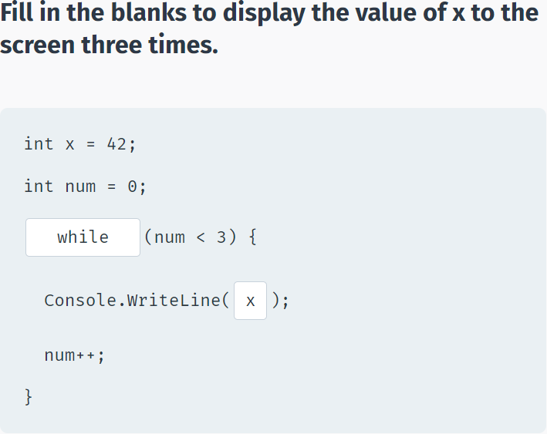

**The while Loop**

The compound arithmetic operators can be used to further control the number of times a loop runs.

**For example:**

using System;

using System.Collections.Generic;

using System.Linq;

using System.Text;

using System.Threading.Tasks;

namespace SoloLearn

{

class Program

{

static void Main(string[] args)

{

int num = 1;

while(num < 6)

{

Console.WriteLine(num);

num+=2;

}

}

}

}

Without a statement that eventually evaluates the loop condition to **false**, the loop will continue indefinitely.

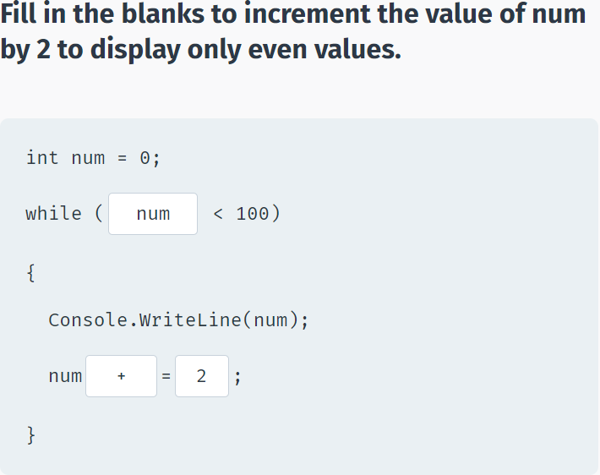

We can shorten the previous example, by incrementing the value of **num** right in the condition:

using System;

using System.Collections.Generic;

using System.Linq;

using System.Text;

using System.Threading.Tasks;

namespace SoloLearn

{

class Program

{

static void Main(string[] args)

{

int num = 0;

while(++num < 6)

Console.WriteLine(num);

}

}

}

What do you think, is there a difference between **while(num++ < 6)** and **while(++num < 6)**?

Yes! The loop **while(++num < 6)** will execute 5 times, because pre-increment increases the value of x before checking the num < 6 condition, while post-increment will check the condition before increasing the value of num, making **while(num++ < 6)** execute 6 times.

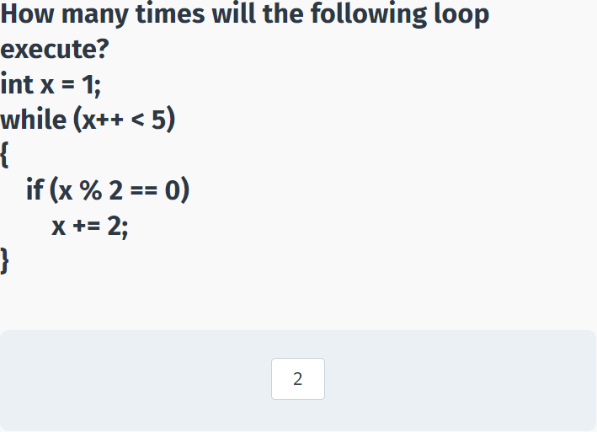

## The for Loop

**The for Loop**

A **for** loop executes a set of statements a specific number of times, and has the syntax:

for ( init; condition; increment ) {

statement(s);

}

A counter is declared once in **init**.

Next, the **condition** evaluates the value of the counter and the body of the loop is executed if the condition is **true**.

After loop execution, the **increment** statement updates the counter, also called the loop control variable.

The condition is again evaluated, and the loop body repeats, only stopping when the condition becomes **false**.

**For example:**

for (int x = 10; x < 15; x++)

{

Console.WriteLine("Value of x: {0}", x);

}

Note the **semicolons** in the syntax.

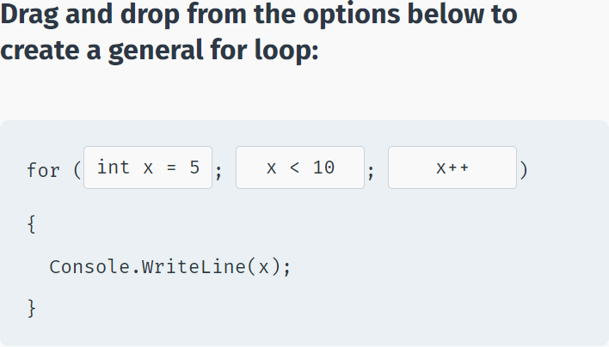

Compound arithmetic operators can be used to further control loop iterations.

**For example:**

for (int x = 0; x < 10; x+=3)

{

Console.WriteLine(x);

}

You can also decrement the counter:

for (int x = 10; x > 0; x-=2)

{

Console.WriteLine(x);

}

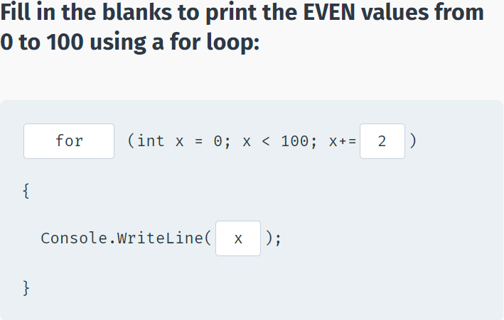

The **init** and **increment** statements may be left out, if not needed, but remember that the semicolons are mandatory.

**For example, the init can be left out:**

int x = 10;

for ( ; x > 0; x -= 3)

{

Console.WriteLine(x);

}

You can have the increment statement in the for loop body:

int x = 10;

for ( ; x > 0 ; )

{

Console.WriteLine(x);

x -= 3;

}

**for (; ;) {}** is an infinite loop.

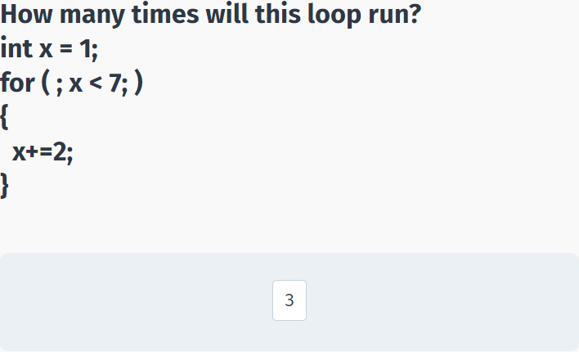

## The do-while Loop

**do-while**

A **do-while** loop is similar to a **while** loop, except that a **do-while** loop is guaranteed to execute at least one time.

**For example:**

int a = 0;

do

{

Console.WriteLine(a);

a++;

} while (a < 5);

Note the **semicolon** after the while statement.

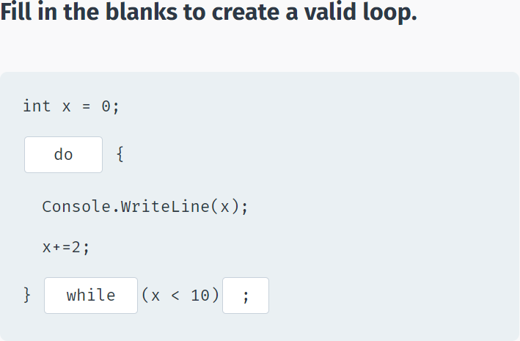

**do-while vs. while**

If the condition of the **do-while** loop evaluates to **false**, the statements in the **do** will still run once:

int x = 42;

do {

Console.WriteLine(x);

x++;

} while(x < 10);

The **do-while** loop executes the statements at least once, and then tests the condition.

The **while** loop executes the statement only after testing condition.

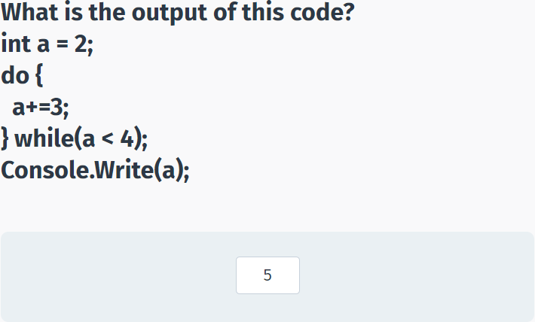

## break and continue

**break**

We saw the use of **break** in the switch statement.

Another use of **break** is in loops: When the **break** statement is encountered inside a loop, the loop is immediately terminated and the program execution moves on to the next statement following the loop body.

**For example:**

int num = 0;

while (num < 20)

{

if (num == 5)

break;

Console.WriteLine(num);

num++;

}

If you are using nested loops (i.e., one loop inside another loop), the **break** statement will stop the execution of the innermost loop and start executing the next line of code after the block.

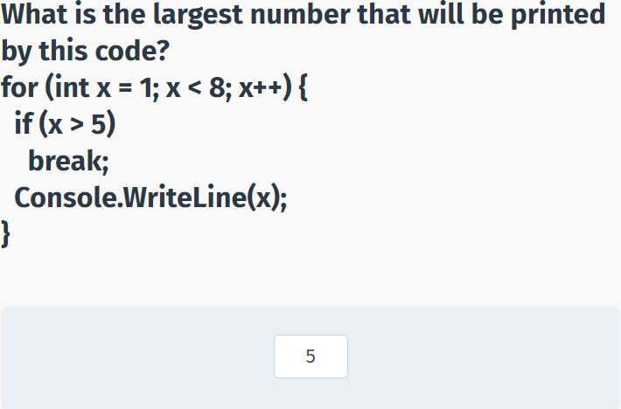

**continue**

The **continue** statement is similar to the **break** statement, but instead of terminating the loop entirely, it skips the current iteration of the loop and continues with the next iteration.

**For example:**

for (int i = 0; i < 10; i++) {

if (i == 5)

continue;

Console.WriteLine(i);

}

As you can see, number 5 is not printed, as the **continue** statement skips the remaining statements of that iteration of the loop.

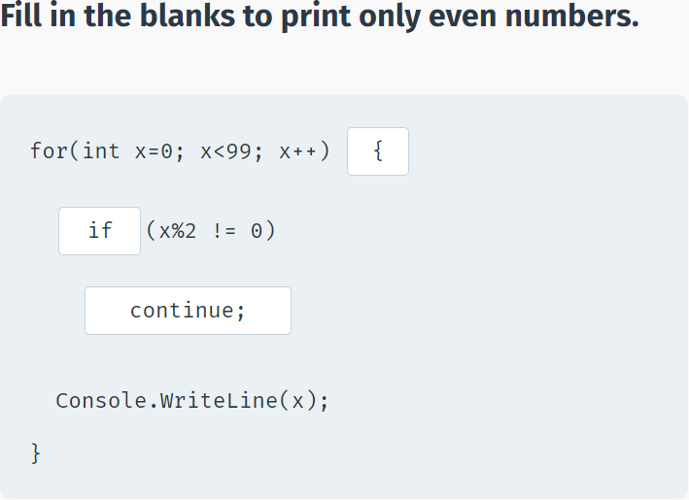

## Logical Operators

**Logical Operators**

Logical operators are used to join multiple expressions and return **true** or **false**.

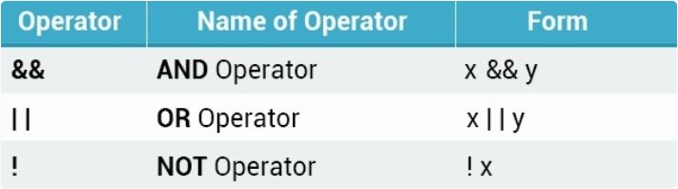

The **AND** operator (&&) works the following way:

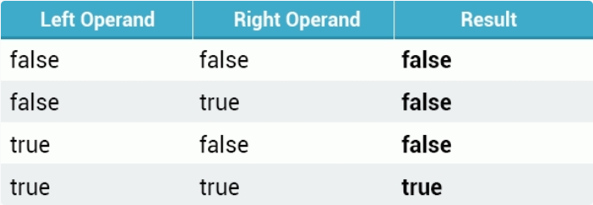

For example, if you wish to display text to the screen only if **age** is greater than 18 AND **money** is greater than 100:

int age = 42;

double money = 540;

if(age > 18 && money > 100) {

Console.WriteLine("Welcome");

}

The AND operator was used to combine the two expressions.

With the AND operator, both operands must be **true** for the entire expression to be **true**.

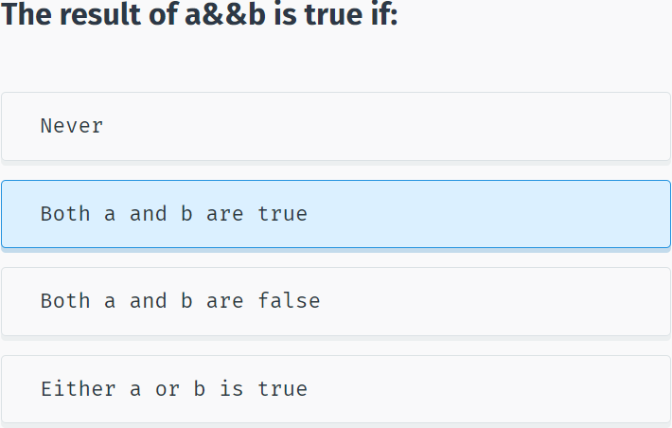

**AND**

You can join more than two conditions:

int age = 42;

int grade = 75;

if(age > 16 && age < 80 && grade > 50)

Console.WriteLine("Hey there");

The entire expression evaluates to **true** only if all of the conditions are **true**.

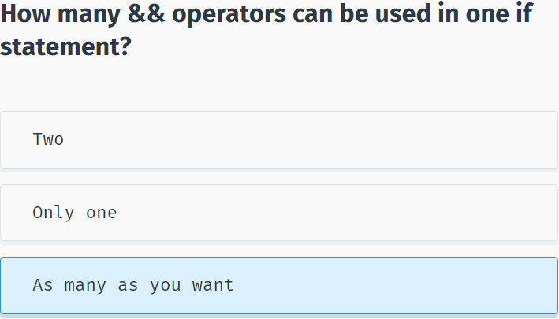

**The OR Operator**

The **OR** operator (||) returns **true** if any one of its operands is **true**.

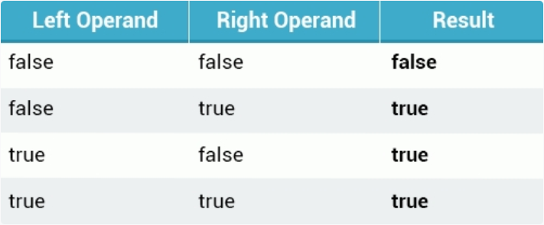

**For example:**

int age = 18;

int score = 85;

if (age > 20 || score > 50) {

Console.WriteLine("Welcome");

}

You can join any number of logical **OR** statements you want.

In addition, multiple **OR** and **AND** statements may be joined together.

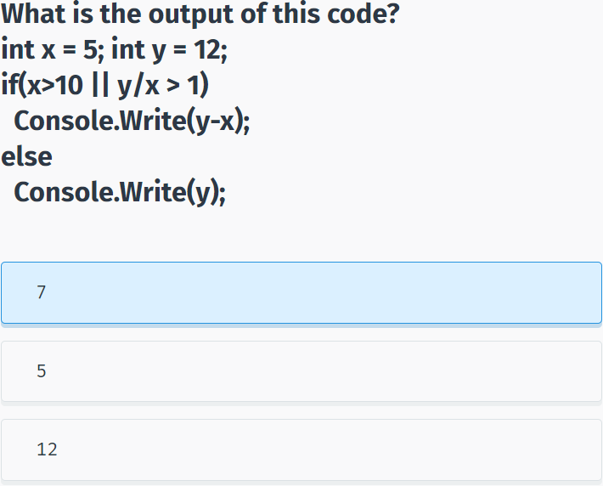

**Logical NOT**

The logical **NOT** (!) operator works with just a single operand, reversing its logical state. Thus, if a condition is **true**, the NOT operator makes it **false**, and vice versa.

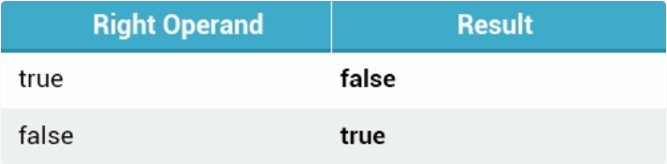

int age = 8;

if ( !(age > 16) ) {

Console.Write("Your age is less than 16");

}

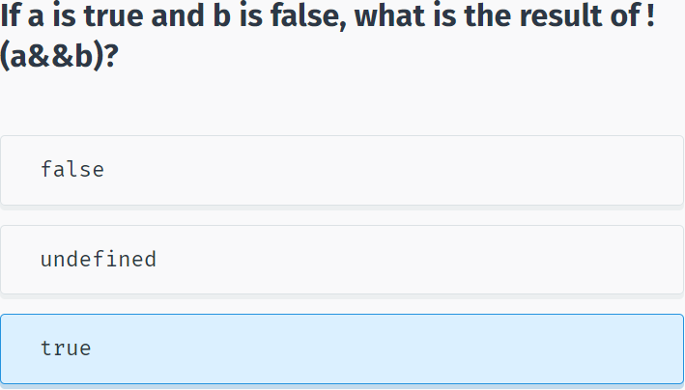

## The Conditional Operator

**The ? : Operator**

**Consider the following example:**

int age = 42;

string msg;

if(age >= 18)

msg = "Welcome";

else

msg = "Sorry";

Console.WriteLine(msg);

The code above checks the value of the **age** variable and displays the corresponding message to the screen.

This can be done in a more elegant and shorter way by using the **?: operator**, which has the following form:

Exp1 ? Exp2 : Exp3;

The ?: operator works the following way: Exp1 is evaluated. If it is true, then Exp2 is evaluated and becomes the value of the entire expression. If Exp1 is false, then Exp3 is evaluated and its value becomes the value of the expression.

So, the example above can be replaced by the following:

int age = 42;

string msg;

msg = (age >= 18) ? "Welcome" : "Sorry";

Console.WriteLine(msg);

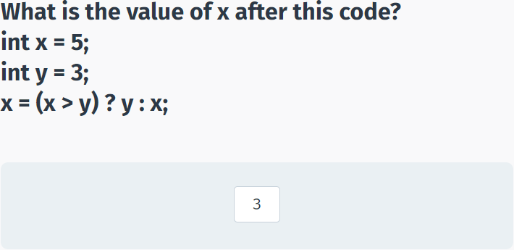

## Basic Calculator

**Basic Calculator**

Now let's create a simple project that repeatedly asks the user to enter two values and then displays their sum, until the user enters exit.

We start with a **do-while** loop that asks the user for input and calculates the **sum**:

do {

Console.Write("x = ");

int x = Convert.ToInt32(Console.ReadLine());

Console.Write("y = ");

int y = Convert.ToInt32(Console.ReadLine());

int sum = x+y;

Console.WriteLine("Result: {0}", sum);

}

while(true);

This code will ask for user input infinitely. Now we need to handle the "exit".

If the user enters a non-integer value, the program will crash from a conversion error. We will learn how to handle errors like that in the coming modules.

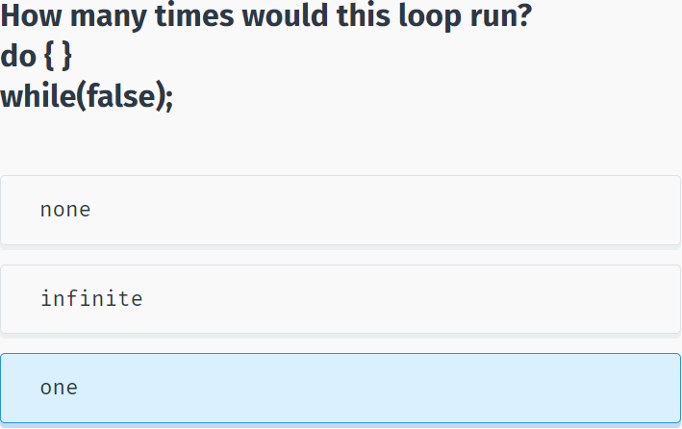

If the user enters "exit" as the value of x, the program should quit the loop. To do this, we can use a **break** statement:

Console.Write("x = ");

string str = Console.ReadLine();

if (str == "exit")

break;

int x = Convert.ToInt32(str);

Here we compare the input with the value "exit" and break the loop.

**So the whole program looks like:**

do {

Console.Write("x = ");

string str = Console.ReadLine();

if (str == "exit")

break;

int x = Convert.ToInt32(str);

Console.Write("y = ");

int y = Convert.ToInt32(Console.ReadLine());

int sum = x + y;

Console.WriteLine("Result: {0}", sum);

}

while (true);

If the user enters "exit" as the value of x, the program should quit the loop.

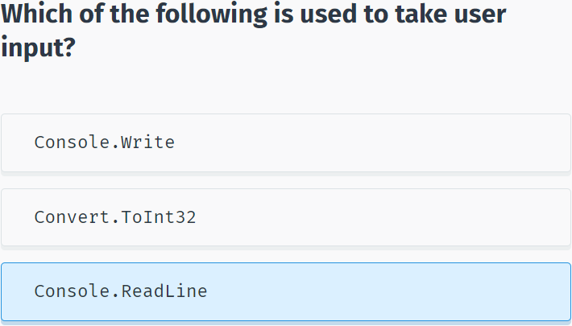

## Module 2 Quiz

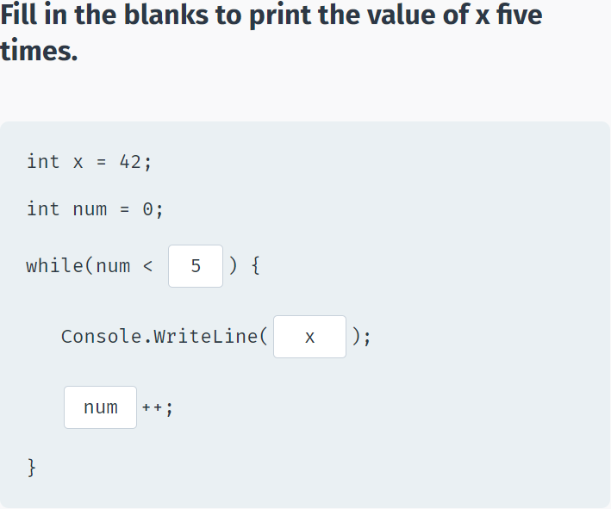

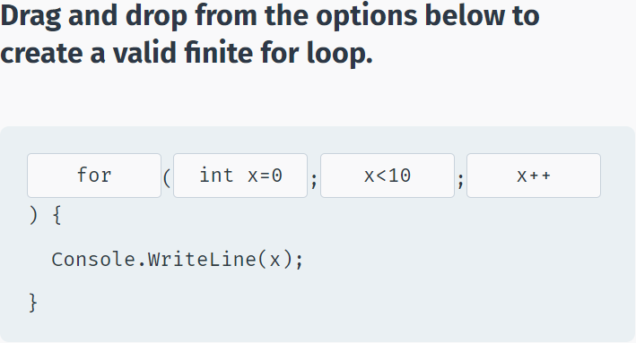

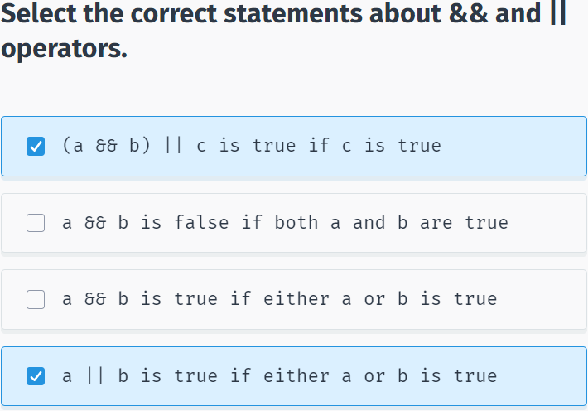

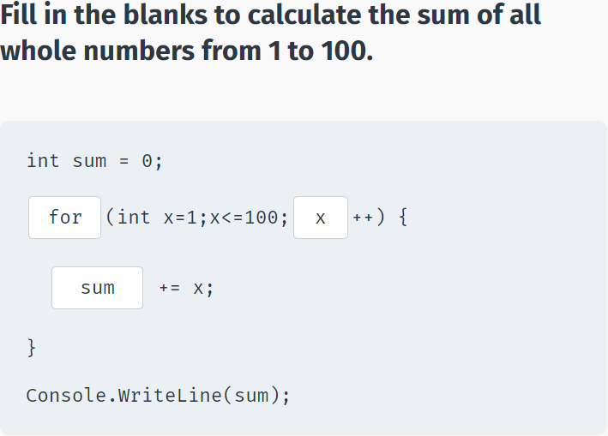

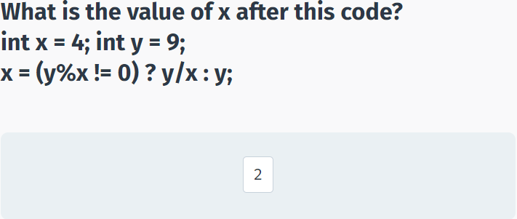

# Methods

## Introduction to Methods

**What is a Method?**

A **method** is a group of statements that perform a particular task.

In addition to the C# built-in methods, you may also define your own.

Methods have many advantages, including:

- Reusable code.

- Easy to test.

- Modifications to a method do not affect the calling program.

- One method can accept many different inputs.

Every valid C# program has at least one method, the **Main** method.

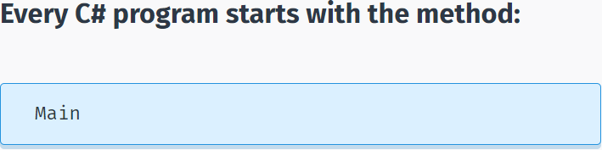

**Declaring Methods**

To use a method, you need to **declare** the method and then **call** it.

Each method declaration includes:

- the return type

- the method name

- an optional list of parameters.

<return type> name(type1 par1, type2 par2, … , typeN parN)

{

List of statements

}

For example, the following method has an int parameter and returns the number squared:

int Sqr(int x)

{

int result = x*x;

return result;

}

The **return** type of a method is declared before its name. In the example above, the return type is **int**, which indicates that the method returns an integer value. When a method returns a value, it must include a **return** statement. Methods that return a value are often used in assignment statements.

Occasionally, a method performs the desired operations without returning a value. Such methods have a return type **void**. In this case, the method cannot be called as part of an assignment statement.

**void** is a basic data type that defines a valueless state.

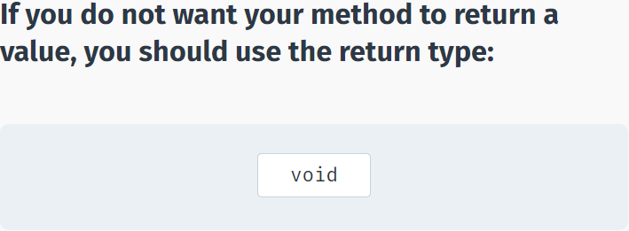

**Calling Methods**

Parameters are optional; that is, you can have a method with no parameters.

As an example, let's define a method that does not return a value, and just prints a line of text to the screen.

static void SayHi()

{

Console.WriteLine("Hello");

}

Our method, entitled **SayHi**, returns **void**, and has no parameters.

To execute a method, you simply call the method by using the name and any required arguments in a statement.

using System;

using System.Collections.Generic;

using System.Linq;

using System.Text;

using System.Threading.Tasks;

namespace SoloLearn

{

class Program

{

static void sayHi()

{

Console.WriteLine("Hello");

}

static void Main(string[] args)

{

sayHi();

}

}

}

The **static** keyword will be discussed later; it is used to make methods accessible in Main.

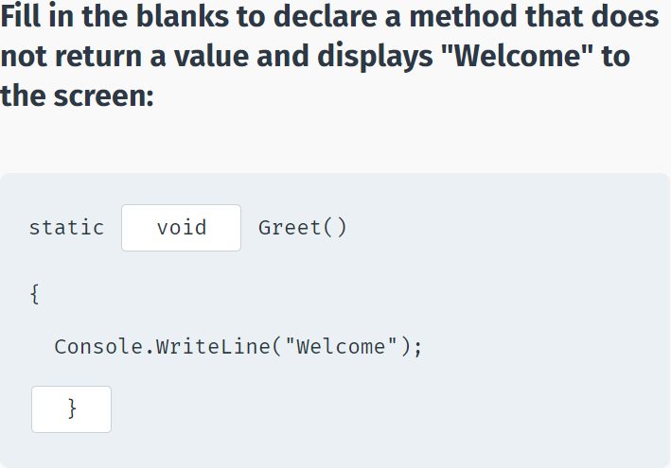

You can call the same method multiple times:

using System;

using System.Collections.Generic;

using System.Linq;

using System.Text;

using System.Threading.Tasks;

namespace SoloLearn

{

class Program

{

static void SayHi()

{

Console.WriteLine("Hello");

}

static void Main(string[] args)

{

SayHi();

SayHi();

SayHi();

}

}

}

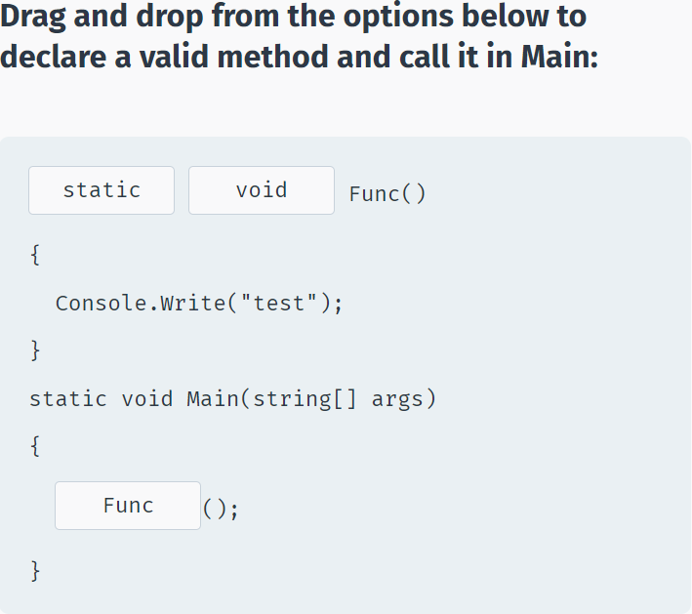

## Method Parameters

**Parameters**

Method declarations can define a list of **parameters** to work with.

Parameters are variables that accept the values passed into the method when called.

**For example:**

void Print(int x)

{

Console.WriteLine(x);

}

This defines a method that takes one integer parameter and displays its value.

Parameters behave within the method similarly to other local variables. They are created upon entering the method and are destroyed upon exiting the method.

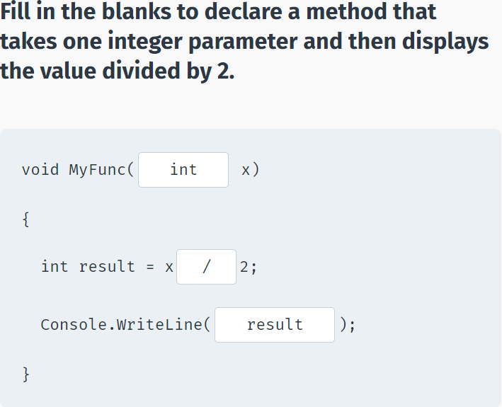

Now you can call the method in Main and pass in the value for its parameters (also called **arguments**):

using System;

using System.Collections.Generic;

using System.Linq;

using System.Text;

using System.Threading.Tasks;

namespace SoloLearn

{

class Program

{

static void Print(int x)

{

Console.WriteLine(x);

}

static void Main(string[] args)

{

Print(42);

}

}

}

The value 42 is passed to the method as an argument and is assigned to the formal parameter x.

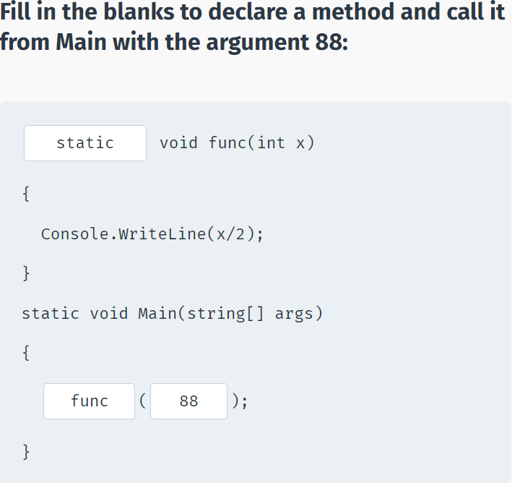

You can pass different arguments to the same method as long as they are of the expected type.

**For example:**

static void Func(int x)

{

Console.WriteLine(x*2);

}

static void Main(string[] args)

{

Func(5);

Func(12);

Func(42);

}

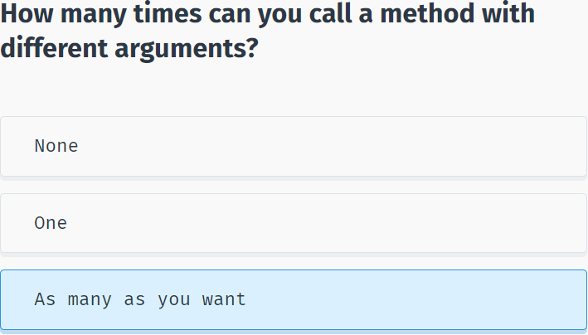

## Multiple Parameters

**Multiple Parameters**

You can have as many parameters as needed for a method by separating them with **commas** in the definition.

Let's create a simple method that returns the sum of two parameters:

int Sum(int x, int y)

{

return x+y;

}

The **Sum** method takes two integers and returns their sum. This is why the return type of the method is **int**. Data **type** and **name** should be defined for each parameter.

Methods return values using the **return** statement.

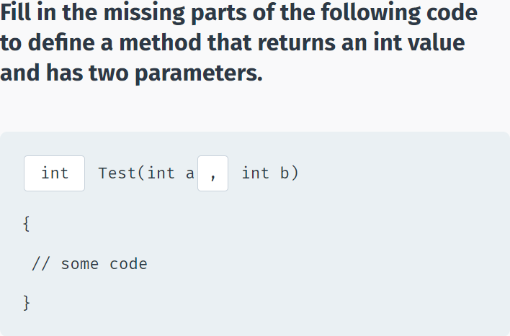

A method call with multiple parameters must separate arguments with **commas**.

For example, a call to **Sum** requires two arguments:

static int Sum(int x, int y)

{

return x+y;

}

static void Main(string[] args)

{

Console.WriteLine(Sum(8, 6));

}

In the call above, the return value was displayed to the console window. Alternatively, we can assign the return value to a variable, as in the code below:

static int Sum(int x, int y)

{

return x+y;

}

static void Main(string[] args)

{

int res = Sum(11, 42);

Console.WriteLine(res);

}

You can add as many parameters to a single method as you want. If you have multiple parameters, remember to separate them with **commas**, both when declaring them and when calling the method.

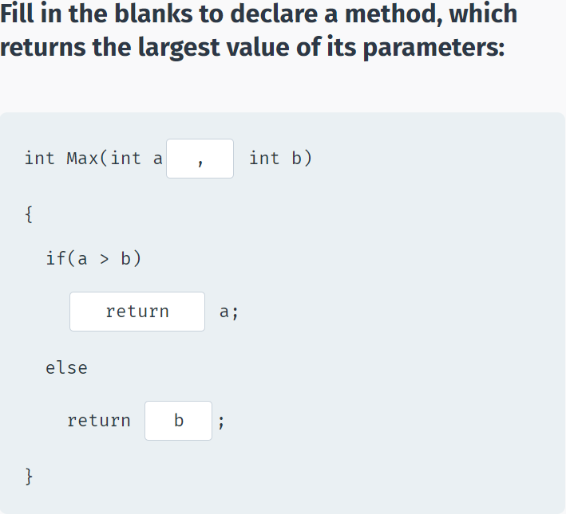

## Optional & Named Arguments

**Optional Arguments**

When defining a method, you can specify a **default value** for optional parameters. Note that optional parameters must be defined after required parameters. If corresponding arguments are missing when the method is called, the method uses the default values.

To do this, assign values to the parameters in the method definition, as shown in this example.

static int Pow(int x, int y=2)

{

int result = 1;

for (int i = 0; i < y; i++)

{

result *= x;

}

return result;

}

The Pow method assigns a default value of 2 to the y parameter. If we call the method without passing the value for the y parameter, the default value will be used.

static int Pow(int x, int y=2)

{

int result = 1;

for (int i = 0; i < y; i++)

{

result *= x;

}

return result;

}

static void Main(string[] args)

{

Console.WriteLine(Pow(6));

Console.WriteLine(Pow(3, 4));

}

As you can see, default parameter values can be used for calling the same method in different situations without requiring arguments for every parameter.

Just remember, that you must have the parameters with default values at the **end** of the parameter list when defining the method.

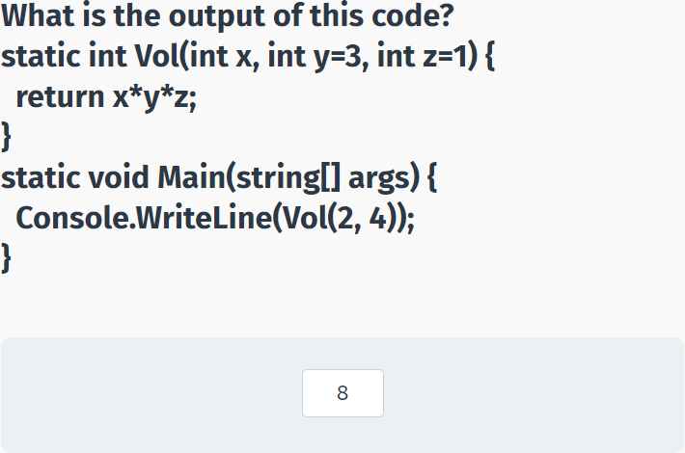

**Named Arguments**

Named arguments free you from the need to remember the order of the parameters in a method call. Each argument can be specified by the matching parameter name.

For example, the following method calculates the area of a rectangle by its height and width:

static int Area(int h, int w)

{

return h * w;

}

When calling the method, you can use the parameter names to provide the arguments in any order you like:

static int Area(int h, int w)

{

return h * w;

}

static void Main(string[] args)

{

int res = Area(w: 5, h: 8);

Console.WriteLine(res);

}

Named arguments use the **name** of the parameter followed by a **colon** and the **value**.

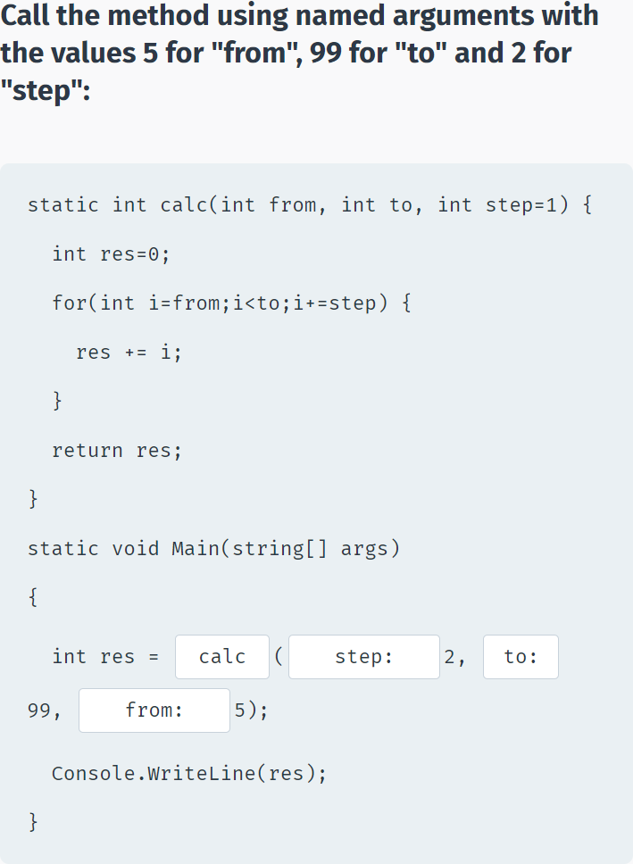

## Passing Arguments

**Passing Arguments**

There are three ways to pass arguments to a method when the method is called: By **value**, By **reference**, and as **Output**.

By **value** copies the argument's value into the method's formal parameter. Here, we can make changes to the parameter within the method without having any effect on the argument.

By default, C# uses call by **value** to pass arguments.

**The following example demonstrates by value:**

static void Sqr(int x)

{

x = x * x;

}

static void Main(string[] args)

{

int a = 3;

Sqr(a);

Console.WriteLine(a);

}

In this case, **x** is the parameter of the **Sqr** method and **a** is the actual argument passed into the method.

As you can see, the **Sqr** method does not change the original value of the variable, as it is passed by **value**, meaning that it operates on the **value**, not the actual variable.

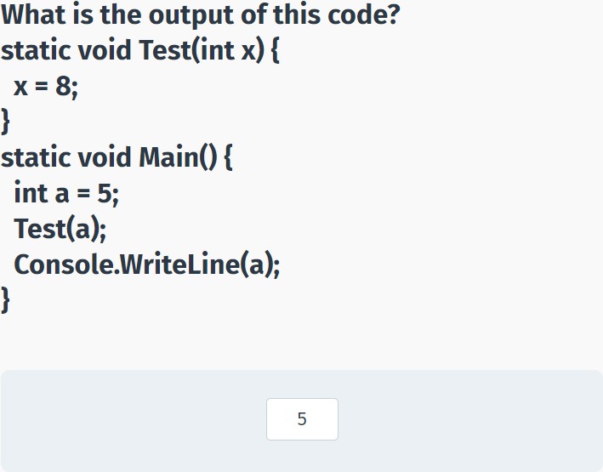

**Passing by Reference**

Pass by **reference** copies an argument's memory address into the formal parameter. Inside the method, the address is used to access the actual argument used in the call. This means that changes made to the parameter affect the argument.

To pass the value by reference, the **ref** keyword is used in both the call and the method definition:

static void Sqr(ref int x)

{

x = x * x;

}

static void Main(string[] args)

{

int a = 3;

Sqr(ref a);

Console.WriteLine(a);

}

The **ref** keyword passes the memory address to the method parameter, which allows the method to operate on the actual variable.

The **ref** keyword is used both when defining the method and when calling it.

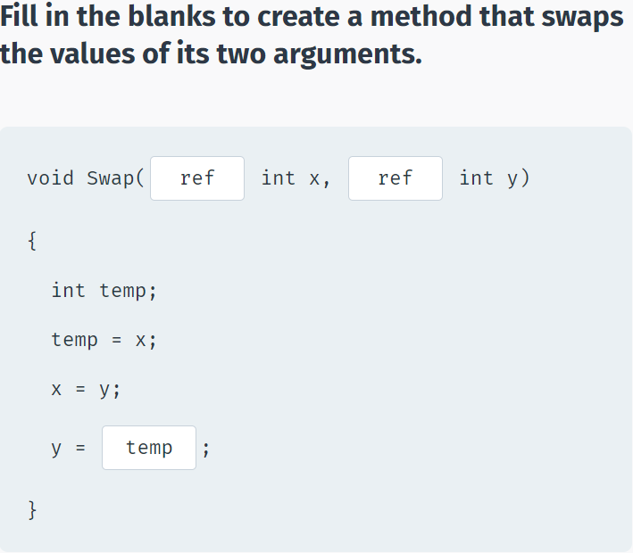

**Passing by Output**

**Output** parameters are similar to reference parameters, except that they transfer data out of the method rather than accept data in. They are defined using the **out** keyword.

The variable supplied for the output parameter need not be initialized since that value will not be used. Output parameters are particularly useful when you need to return multiple values from a method.

**For example:**

static void GetValues(out int x, out int y)

{

x = 5;

y = 42;

}

static void Main(string[] args)

{

int a, b;

GetValues(out a, out b);

Console.WriteLine(a+" "+b);

}

Unlike the previous reference type example, where the value 3 was referred to the method, which changed its value to 9, output parameters get their value from the method (5 and 42 in the above example).

Similar to the **ref** keyword, the **out** keyword is used both when defining the method and when calling it.

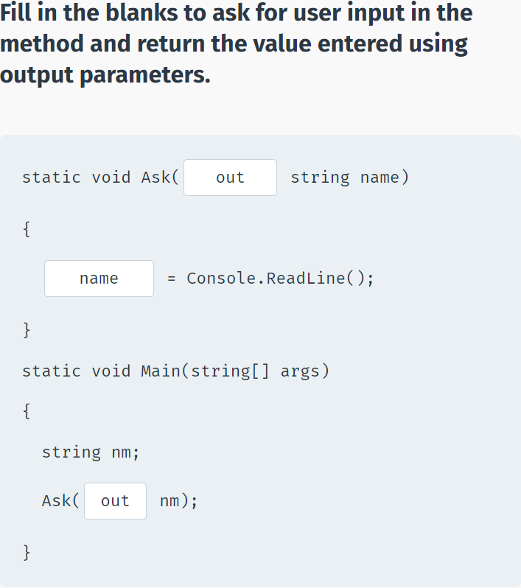

## Method Overloading

**Overloading**

Method **overloading** is when multiple methods have the **same name**, but **different parameters**.

For example, you might have a **Print** method that outputs its parameter to the console window:

void Print(int a)

{

Console.WriteLine("Value: "+a);

}

The + operator is used to concatenate values. In this case, the value of a is joined to the text "Value: ".

This method accepts an integer **argument** only.

Overloading it will make it available for other types, such as **double**

void Print(double a)

{

Console.WriteLine("Value: "+a);

}

Now, the same **Print** method name will work for both integers and doubles.

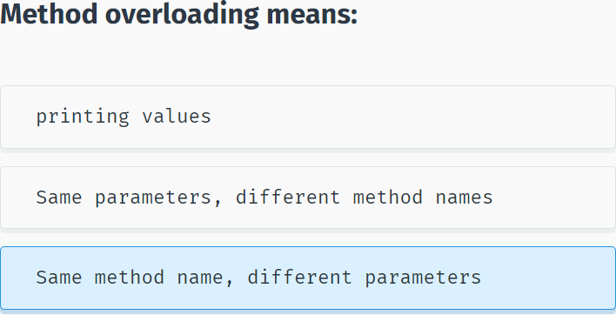

When overloading methods, the definitions of the methods must differ from each other by the types and/or number of parameters.

When there are overloaded methods, the method called is based on the arguments. An **integer** argument will call the method implementation that accepts an **integer** parameter. A **double** argument will call the implementation that accepts a **double** parameter. Multiple arguments will call the implementation that accepts the same number of arguments.

static void Print(int a) {

Console.WriteLine("Value: " + a);

}

static void Print(double a) {

Console.WriteLine("Value: " + a);

}

static void Print(string label, double a) {

Console.WriteLine(label + a);

}

static void Main(string[] args)

{

Print(11);

Print(4.13);

Print("Average: ", 7.57);

}

You cannot overload method declarations that differ only by return type.

The following declaration results in an **error**.

**int** PrintName(int a) { }

**float** PrintName(int b) { }

**double** PrintName(int c) { }

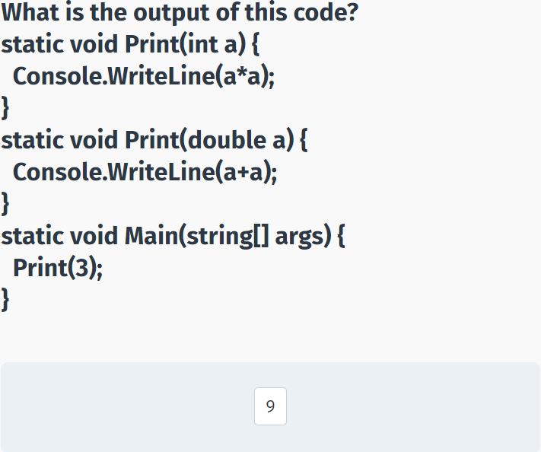

## Recursion

**Recursion**

A **recursive** method is a method that calls itself.

One of the classic tasks that can be solved easily by recursion is calculating the **factorial** of a number.

In mathematics, the term **factorial** refers to the product of all positive integers that are less than or equal to a specific non-negative integer (n). The factorial of n is denoted as **n!**

**For example:**

4! = 4 * 3 * 2 * 1 = 24

A recursive method is a method that calls itself.

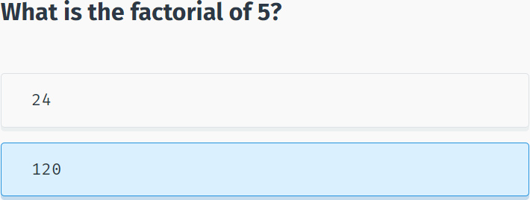

As you can see, a factorial can be thought of as repeatedly calculating num * num-1 until you reach 1.

Based on this solution, let's define our method:

static int Fact(int num) {

if (num == 1) {

return 1;

}

return num * Fact(num - 1);

}

In the **Fact** recursive method, the **if** statement defines the exit condition, a base case that requires no recursion. In this case, when **num** equals one, the solution is simply to return 1 (the factorial of one is one).

The recursive call is placed after the exit condition and returns **num** multiplied by the factorial of n-1.

For example, if you call the **Fact** method with the argument 4, it will execute as follows:

return 4*Fact(3), which is 4*3*Fact(2), which is 4*3*2*Fact(1), which is 4*3*2*1.

**Now we can call our Fact method from Main:**

static int Fact(int num) {

if (num == 1) {

return 1;

}

return num * Fact(num - 1);

}

static void Main(string[] args)

{

Console.WriteLine(Fact(6));

}

The factorial method calls itself, and then continues to do so, until the argument equals 1. The exit condition prevents the method from calling itself indefinitely.

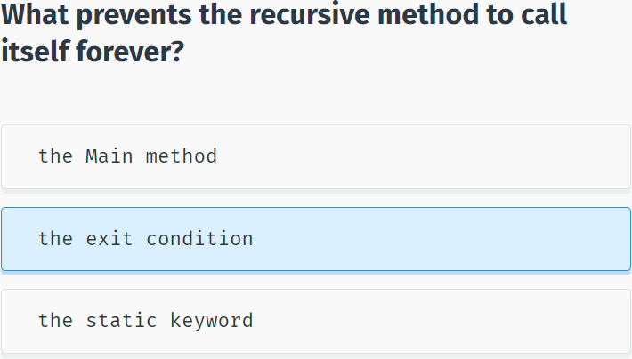

## Making a Pyramid

**Making a Pyramid**

Now, let's create a method that will display a pyramid of any height to the console window using star (*) symbols.

Based on this description, a parameter will be defined to reflect the number of rows for the pyramid.

**So, let's start by declaring the method:**

static void DrawPyramid(int n)

{

//some code will go here

}

**DrawPyramid** does not need to return a value and takes an integer parameter n.

In programming, the step by step logic required for the solution to a problem is called an **algorithm**. The algorithm for MakePyramid is:

1. The first row should contain one star at the top center of the pyramid. The center is calculated based on the number of rows in the pyramid.

2. Each row after the first should contain an odd number of stars (1, 3, 5, etc.), until the number of rows is reached.

Based on the algorithm, the code will use for loops to display spaces and stars for each row:

using System;

using System.Collections.Generic;

using System.Linq;

using System.Text;

using System.Threading.Tasks;

namespace SoloLearn

{

class Program

{

static void DrawPyramid(int n)

{

for (int i=1; i<=n; i++)

{

for (int j=i; j<=n; j++)

{

Console.Write(" ");

}

for (int k=1; k<=2*i-1; k++)

{

Console.Write("*"+" ");

}

Console.WriteLine();

}

}

static void Main(string[] args)

{

DrawPyramid(5);

}

}

}

The first **for** loop that iterates through each row of the pyramid contains two **for** loops.

The first inner loop displays the spaces needed before the first star symbol. The second inner loop displays the required number of stars for each row, which is calculated based on the formula (2*i-1) where i is the current row.

The final **Console.WriteLine();** statement moves the cursor to the next row.

Now, if we call the **DrawPyramid** method, it will display a pyramid having the number of rows we pass to the method.

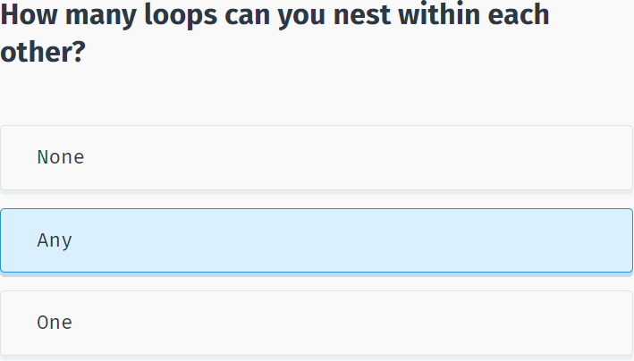

## Module 3 Quiz

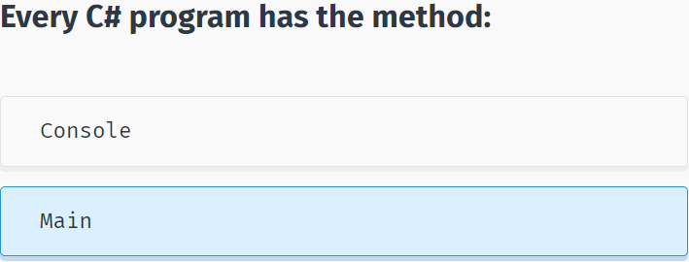

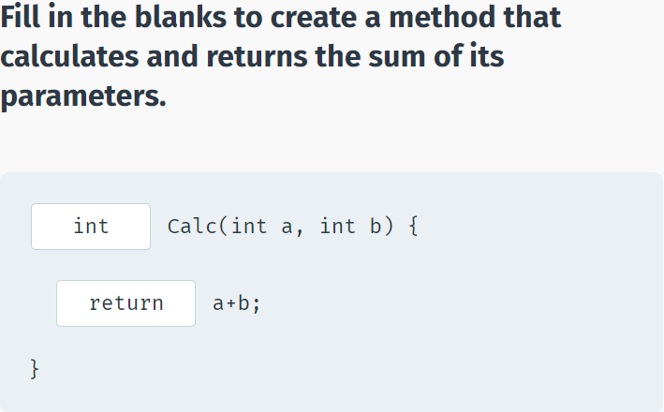

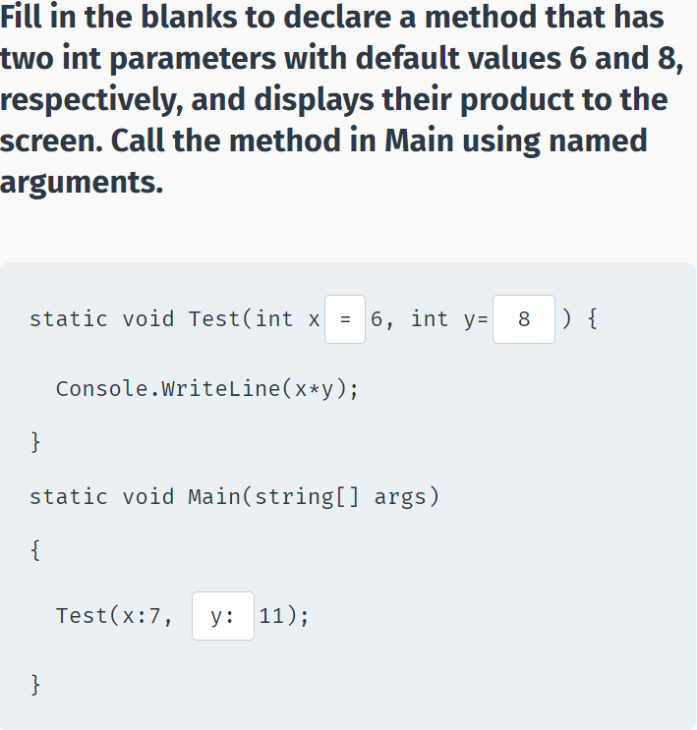

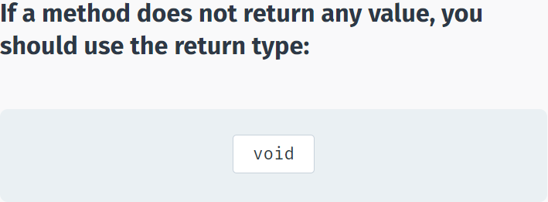

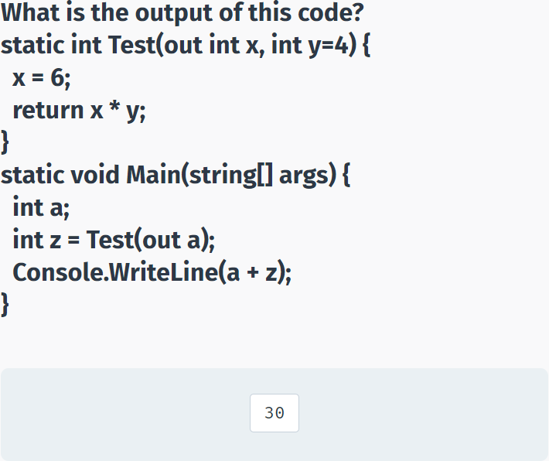

# Classes & Objects

## Classes & Objects

**Classes**

As we have seen in the previous modules, built-in data types are used to store a single value in a declared variable. For example, **int x** stores an integer value in a variable named **x**.

In object-oriented programming, a **class** is a data type that defines a set of variables and methods for a declared **object**.

For example, if you were to create a program that manages bank accounts, a **BankAccount** class could be used to declare an object that would have all the properties and methods needed for managing an individual bank account, such as a **balance** variable and **Deposit** and **Withdrawal** methods.

A class is like a **blueprint**. It defines the data and behavior for a type. A class definition starts with the keyword **class** followed by the class name. The class body contains the data and actions enclosed by curly braces.

class BankAccount

{

//variables, methods, etc.

}

The class defines a data type for objects, but it is not an object itself. An **object** is a concrete entity based on a class, and is sometimes referred to as an **instance of a class**.

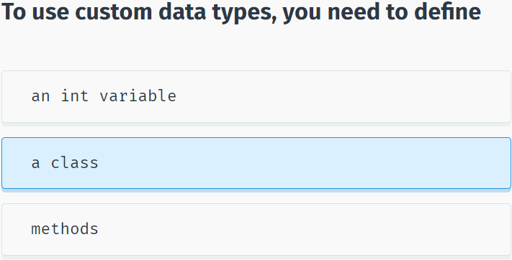

**Objects**

Just as a built-in data type is used to declare multiple variables, a class can be used to declare multiple **objects**. As an analogy, in preparation for a new building, the architect designs a blueprint, which is used as a basis for actually building the structure. That same blueprint can be used to create multiple buildings.

Programming works in the same fashion. We define (design) a class that is the blueprint for creating objects.

In programming, the term **type** is used to refer to a class **name**: We're creating an object of a particular **type**.

Once we've written the class, we can create objects based on that class. Creating an object is called **instantiation**.

An object is called an instance of a class.

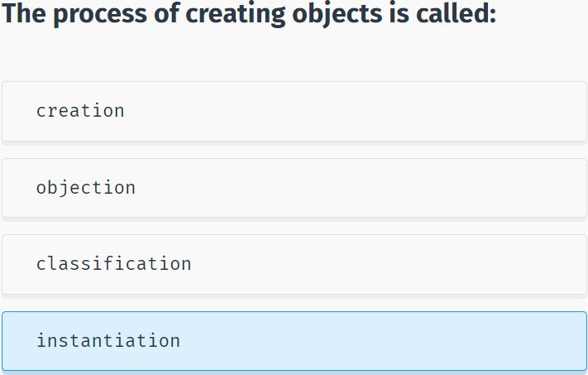

Each object has its own characteristics. Just as a person is distinguished by name, age, and gender, an object has its own set of values that differentiate it from another object of the same type.

The characteristics of an object are called **properties**.

Values of these properties describe the current state of an object. For example, a Person (an object of the class Person) can be 30 years old, male, and named Antonio.

Objects aren't always representative of just physical characteristics.

For example, a programming object can represent a date, a time, and a bank account. A bank account is not tangible; you can't see it or touch it, but it's still a well-defined object because it has its own properties.

Let's move on and see how to create your own custom classes and objects!

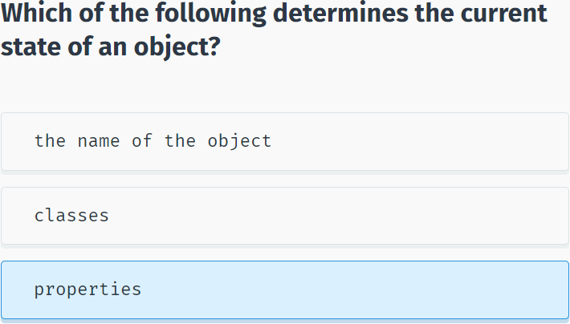

## Value & Reference Types

**Value Types**

C# has two ways of storing data: by **reference** and by **value**.

The built-in data types, such as int and double, are used to declare variables that are **value types**. Their value is stored in memory in a location called the **stack**.

For example, the declaration and assignment statement **int x = 10**; can be thought of as:

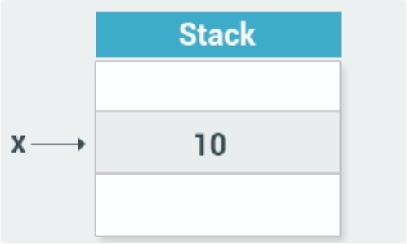

The value of the variable x is now stored on the **stack**.

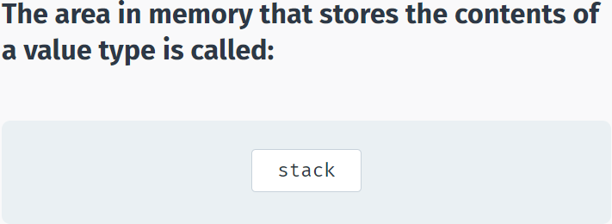

**Reference Types**

**Reference** types are used for storing objects. For example, when you create an object of a class, it is stored as a reference type.

Reference types are stored in a part of the memory called the **heap**.

When you instantiate an object, the data for that object is stored on the heap, while its heap memory address is stored on the stack.

That is why it is called a reference type - it contains a reference (the memory address) to the actual object on the heap.

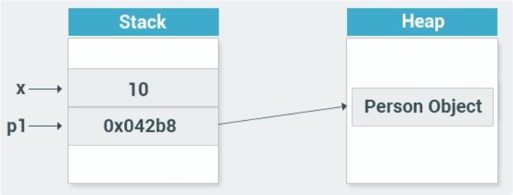

As you can see, the **p1** object of type Person on the stack stores the memory address of the heap where the actual object is stored.

**Stack** is used for static memory allocation, which includes all your value types, like x.

**Heap** is used for dynamic memory allocation, which includes custom objects, that might need additional memory during the runtime of your program.

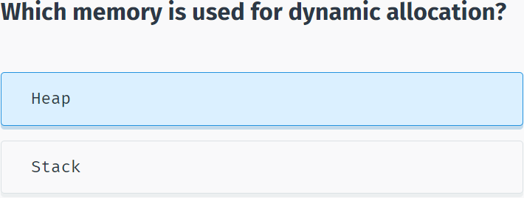

## Class Example

**Example of a Class**

Let’s create a **Person** class:

class Person

{

int age;

string name;

public void SayHi()

{

Console.WriteLine("Hi");

}

}

The code above declares a class named **Person**, which has **age** and **name** fields as well as a **SayHi** method that displays a greeting to the screen.

You can include an access modifier for fields and methods (also called **members**) of a class. **Access modifiers** are keywords used to specify the accessibility of a member.

A member that has been defined **public** can be accessed from outside the class, as long as it's anywhere within the scope of the class object. That is why our **SayHi** method is declared **public**, as we are going to call it from outside of the class.

You can also designate class members as **private** or **protected**. This will be discussed in greater detail later in the course. If no access modifier is defined, the member is **private** by default.

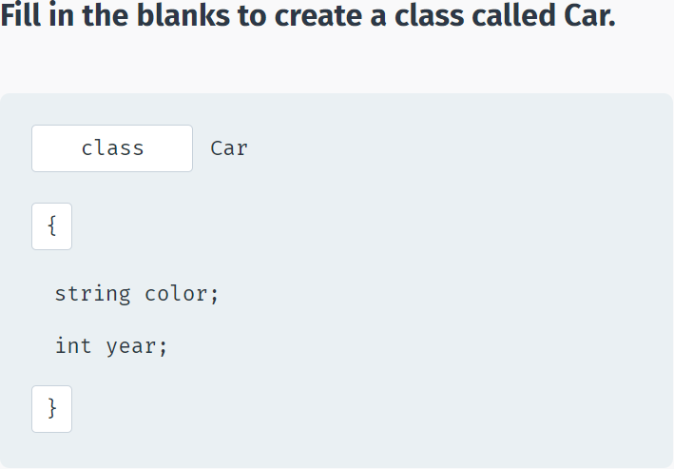

Now that we have our Person class defined, we can instantiate an object of that type in Main.

The **new** operator instantiates an object and returns a reference to its location:

using System;

using System.Collections.Generic;

using System.Linq;

using System.Text;

using System.Threading.Tasks;

namespace SoloLearn

{

class Program

{

class Person {

int age;

string name;

public void SayHi() {

Console.WriteLine("Hi");

}

}

static void Main(string[] args)

{

Person p1 = new Person();

p1.SayHi();

}

}

}

The code above declares a Person object named **p1** and then calls its public **SayHi()** method.

Notice the **dot operator (.)** that is used to access and call the method of the object.

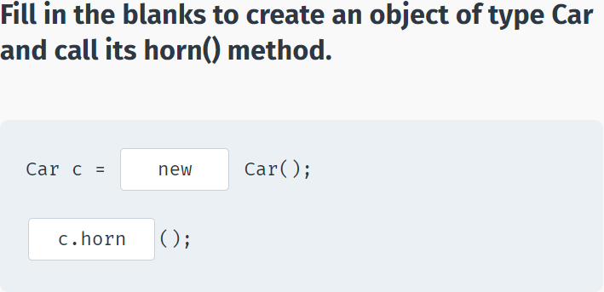

You can access all public members of a class using the dot operator.

Besides calling a method, you can use the dot operator to make an assignment when valid.

**For example:**

class Dog

{

public string name;

public int age;

}

static void Main(string[] args)

{

Dog bob = new Dog();

bob.name = "Bobby";

bob.age = 3;

Console.WriteLine(bob.age);

}

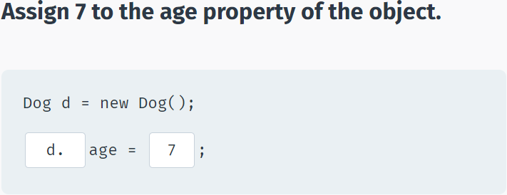

## Encapsulation

**Encapsulation**

Part of the meaning of the word **encapsulation** is the idea of "surrounding" an entity, not just to keep what's inside together, but also to protect it.

In programming, encapsulation means more than simply combining members together within a class; it also means restricting access to the inner workings of that class.

Encapsulation is implemented by using **access modifiers**. An access modifier defines the scope and visibility of a class member.

Encapsulation is also called **information hiding**.

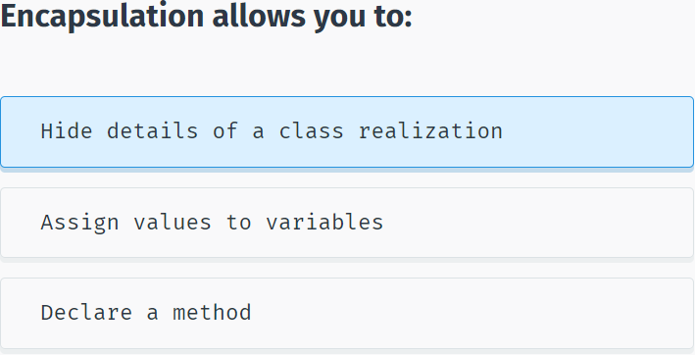

C# supports the following access modifiers: **public, private, protected, internal, protected internal**.

As seen in the previous examples, the **public** access modifier makes the member accessible from the outside of the class.

The **private** access modifier makes members accessible only from within the class and hides them from the outside.

**protected** will be discussed later in the course.

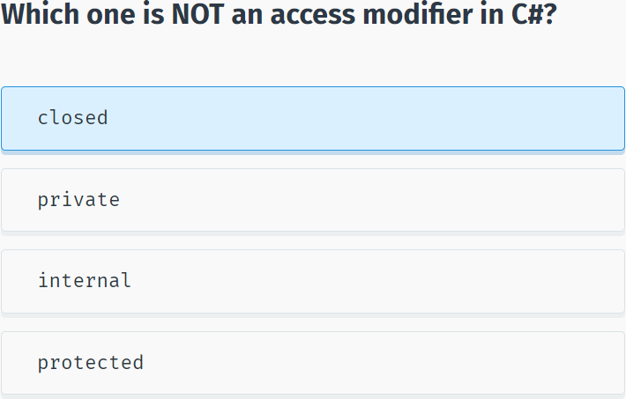

# Arrays & Strings

# More On Classes

# Inheritance & Polymorphism

# Structs, Enums, Exceptions & Files

# Generics

# Dictionary

## Noun

basic concepts : những khái niệm cơ bản

language : ngôn ngữ

applications : những ứng dụng

Web services : dịch vụ web

client-server : máy khách-máy chủ

database : cơ sở dữ liệu

.NET Framework : là một nền tảng lập trình

Common Language Runtime : ngôn ngữ thực thi tổng quát

class library : lớp thư viện

foundation : nền tảng

memory management : quản lý bộ nhớ

collection : bộ sưu tập

aspects of code : các khía cạnh của code

execution time : thời gian thực hiện

accuracy : sự chính xác

core services : những dịch vụ cốt lỗi

task : nhiệm vụ

various functionalities : các chức năng khác nhau

components : các thành phần

variables : biến (ví dụ f(x) = x2 ->x chính là biến trong hàm)

memory location : vị trí bộ nhớ

name : tên

data type : kiểu dữ liệu

underscore character : ‘_’ dấu gạch dưới

semicolon : ‘;’ dấu chấm phẩy

commas : ‘,’ dấu phẩy

single quotes : “ ‘ “ dấu nháy đơn

parentheses : ‘(‘ dấu ngoặc đơn

curly braces : ‘{‘ dấu ngoặc nhọn

quotation marks : ‘ “ ‘ dấu ngoặc kép

two slashes : ‘//’ 2 dấu xẹt

information : thông tin

identifier : sự định danh

statement : câu lệnh

operation : sự điều hành

sequence : sự liên tục

character : chữ cái

additional software : phần mềm bổ sung

classes : các lớp

methods : các phương thức

arguments : các đối số

namespaces : không gian tên

general message : thông báo chung

text-only interface : giao diện thuần văn bản

a line terminator : dấu xuống dòng

console : bàn điều khiển

cursor : con trỏ

formatted string : chuỗi định dạng

syntax : cú pháp

conversion : sự chuyển đổi

alternatives : lựa chọn thay thế

default : mặc định

precedence : quyền ưu tiên

Operator : hệ điều hành

compound assignment operators : toán tử gán ghép

Prefix : tiền tố

Postfix : hậu tố

nested if Statements : lệnh if lồng nhau

equality : sự bằng nhau

increment : sự gia tăng

decrement : sự giảm dần

iteration : sự lặp lại

loop : vòng lặp

expression : biểu thức

reusable code : tái sử dụng code

parameter : tham số

rectangle : hình chữ nhật

Recursion : đệ quy

Pyramid : kim tự tháp

algorithm : thuật toán

properties : tính chất

instance : ví dụ

instantiation : sự tức thời

characteristic : nét đặc trưng

Stack : ngăn xếp - bộ nhớ tĩnh lưu các biến biết trước dung lượng

Heap : chất đống - bộ nhớ động lưu các dữ liệu ko biết trước dung lượng

encapsulation : sự đóng gói

access modifier : công cụ sửa đổi truy cập

## Verb

enable : cho phép, kích hoạt

build : xây dựng

create : chế tạo

run : chạy

consists of : bao gồm

collect : sưu tầm

accomplish : đạt được

file access : truy cập file

reserves : dự trữ

store : lưu trữ

declare : khai báo

specify : xác định

complete : hoàn thành

descriptive of : mô tả về

contain : lưu trữ

perform : biểu diễn

install : cài đặt

Pressing any key : nhấn phím bất kỳ

pass data : truyền dữ liệu

display : trưng bày

include : bao gồm

prompt : nhắc nhở

assign : chỉ định

convert : chuyển đổi

expect : mong đợi

follow : theo

facilitate : tạo điều kiện

alter : thay đổi

evaluate : đánh giá

continue : tiếp tục

break : phá vỡ

indicate : biểu thị

define : định nghĩa

input : đầu vào

output : đầu ra

value : theo giá trị

reference : theo tham chiếu

concatenate values : nối các giá trị

determine : xác định

## Adjective

elegant : thanh lịch

variety of : đa dạng

secure : an toàn

robust : mạnh mẽ

upcoming : sắp tới

complex : phức tạp

important : quan trọng

understandable : có thể hiểu được

readable : có thể đọc được

True : đúng

False : sai

different : khác nhau

empty : bỏ trống

explanatory : được giải thích

conditional : có điều kiện

entire : toàn bộ

distinguished : được phân biệt

dynamic : năng động

private : riêng tư

public : cộng đồng

protected : được bảo vệ

## Other

such as : như là

extensively : một cách chuyên sâu

automatically : một cách tự động

implicitly : ngầm hiểu

explicitly : rõ ràng

indefinitely : vô thời hạn

# END!